COMPETITOR RESEARCH AND ANALYSIS
“NEW U” APPLICATION
KENNETH TEO ZHI HAO

*All applications shown are downloaded from the Google Play store, screenshots taken using HUAWEI MATE 10 pro. Size and placement of buttons and text may differ from phone to phone.
Adidas Training Application
Adidas Training app aims to promote exercise through short workout sessions that can be done at home without any equipment. Focus is ease of use as well as guidance to help people who are new to exercising in general, with each exercise having videos to teach you how to perform them correctly. The app provides a huge array of bodyweight workout routines that usually last around 10 to 30minutes. However, the app does not allow you to customise your workout completely. Generally easy to use.
The app makes use of mainly stepwise navigation models for most of the processes as this is useful to prevent users from getting lost while navigating through the menu. Consistent colours of white and green, coupled with its minimal design and rounded shapes gives it a cool, easy going and accepting vibe to the user. This is good for beginners because they will feel welcomed and not pressured.
This analysis will be looking at onboarding process, customising process and the workout process of this application.
Onboarding
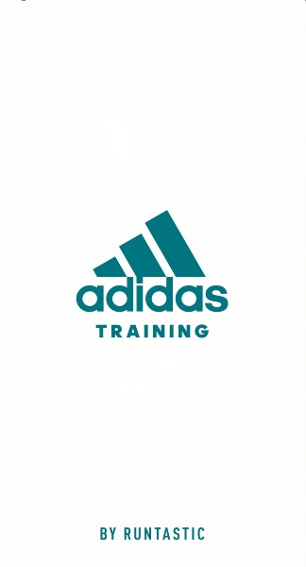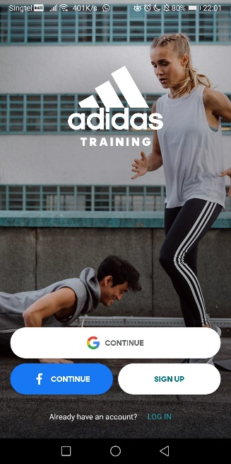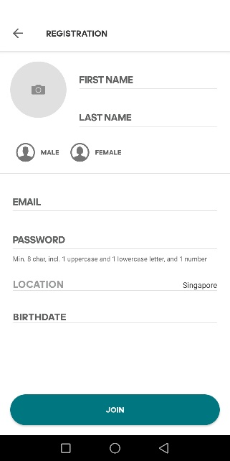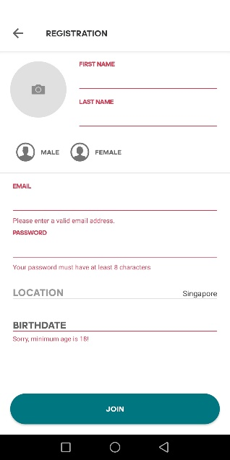
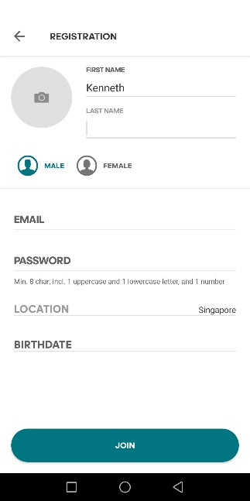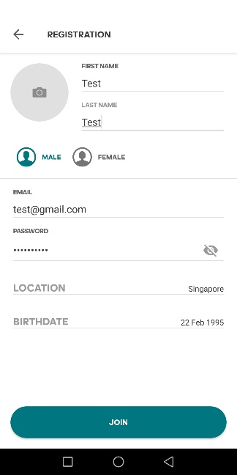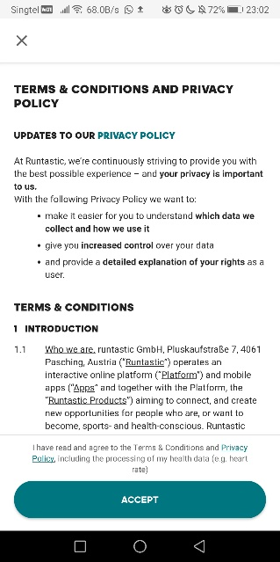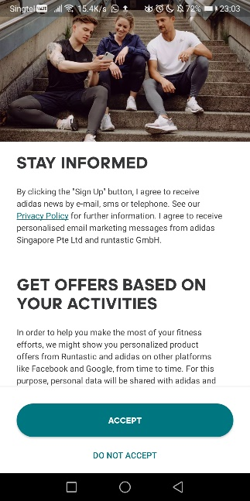

Analysis on onboarding
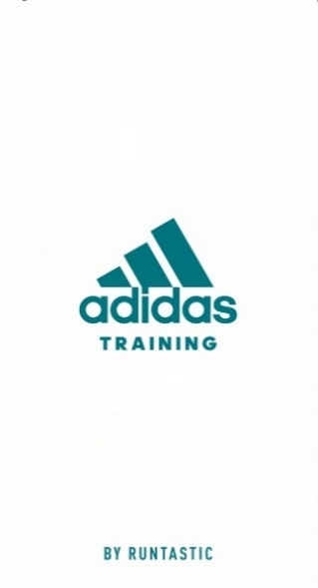
On launching the application, it provides a huge splash screen that shows you the adidas logo on white background, with huge contrast that provides a professional look.

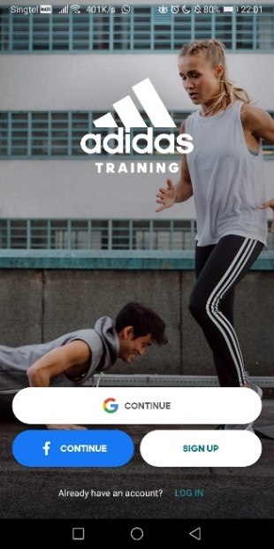
Login screen, repeating the logo again. This time with a photograph of the woman eyes focusing right at the logo which directs the user to look at it again. The bottom part is the man facing the login options provided which prompts the user to login into the app.

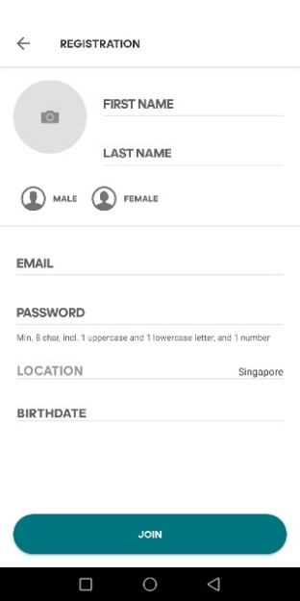
Sign up screen brings the user to the registration menu with huge text that tell the user exactly what information is required at first glance. When the field is filled up, the text reduces in size so that it does not take attention away from the areas that are blank.

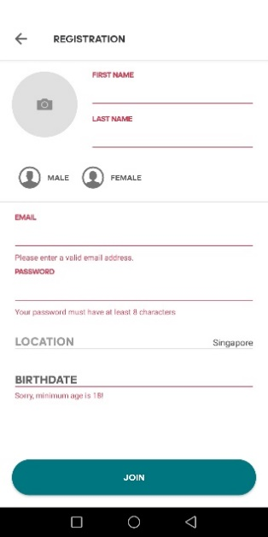
Small red text and lines highlight the areas that are required to be filled if the user taps on the “JOIN” button without filling them up.

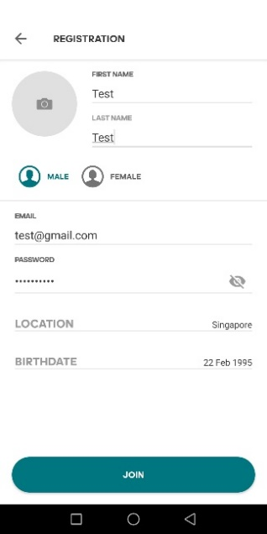
One inconsistency found in this process is the “LOCATION” and “BIRTHDATE” texts that do not shrink in size after it has been field up and is quite jarring to look at. Another one is the gender selection where it is buttons that turn green when selected. Is the gender the focus of the onboarding process? That is what I perceived when I went through it.

The next page they present you with the terms and conditions and change the back-button icon to a cross icon. This is misleading as it meant that I do not have to accept this because it looks like a pop up that I can simply close, however closing it brings the user back to the registration page.

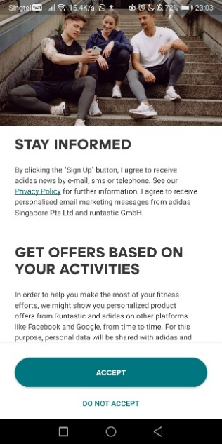
After accepting terms and conditions, it brings the user to the newsletter screen which has a different layout again, where did the back or cross button go? The use of the huge picture that look like friends sharing information leads directly to “STAY INFORMED” which is a good way of getting users to sign up for it, as well as the “accept” option being highlighted compared to “do not accept” which is the undesirable action.

Customizing
The next process right after onboarding is a short survey that helps to app customise the workout suggestion to the needs of the user. It is a relatively simple process as each screen only provides 4 options.
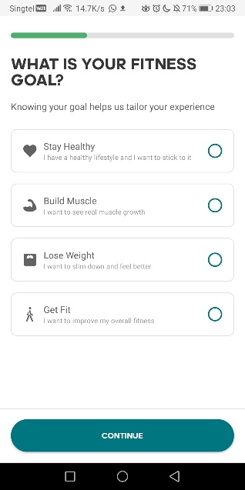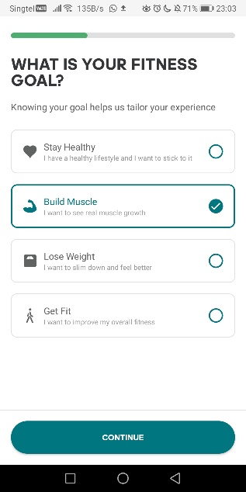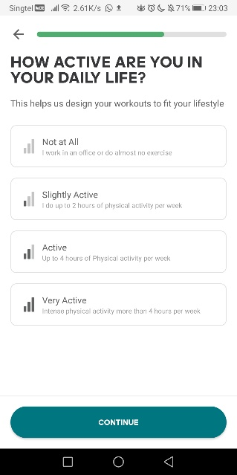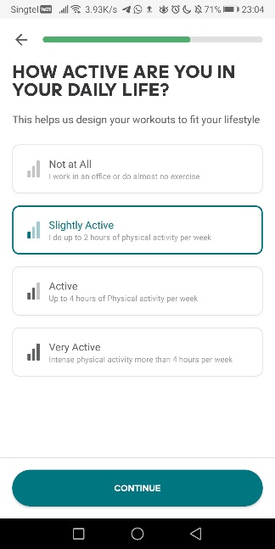
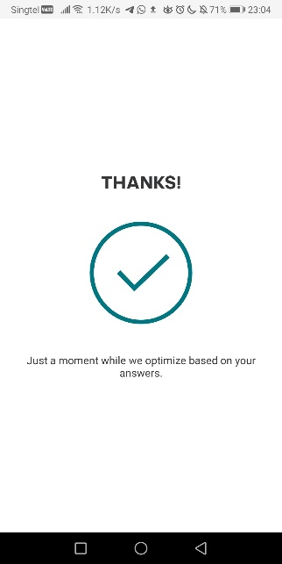
Analysis on customizing
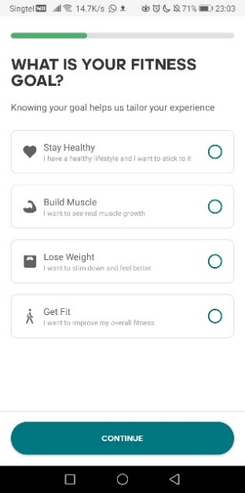
The progress bar at the top of the screen clearly tells the shower the progress, although it would be better if they broke it into sections so that users are able to tell how many pages are left to be filled. The huge font size of the question draws the user attention and the options are easy to understand with short lines of text.

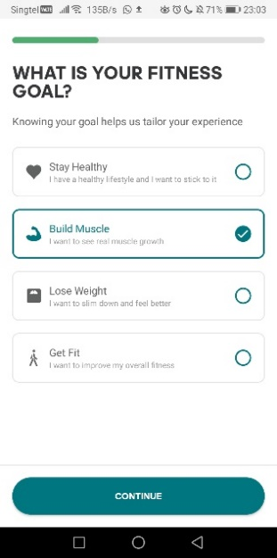
Selecting the option, highlights it with a thin green line and a check mark to avoid confusion.

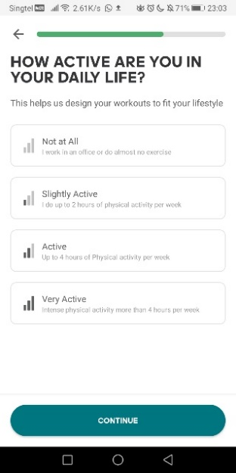
The next page brings back the back button seen at the top left to show the user that they can go back to change their selection if they made a mistake earlier.

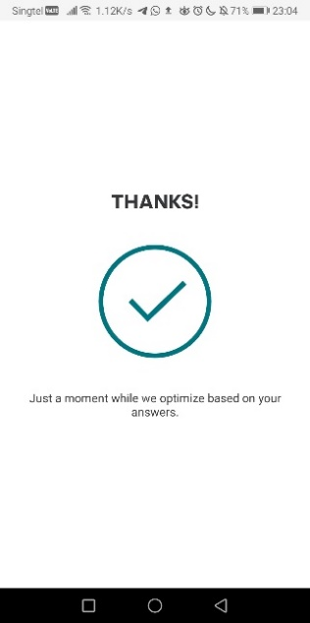
A simple thank you message with a huge check mark to show completion of task.

Workout
The last process is the workout, after the survey the app recommends a workout routine to get the user started straight away. It is a good way to prompt users to use the app in order to get them hooked.
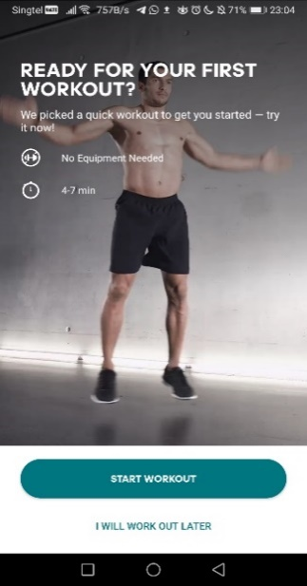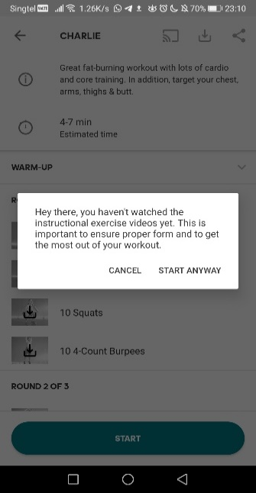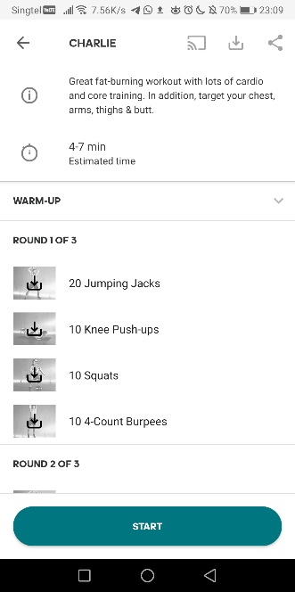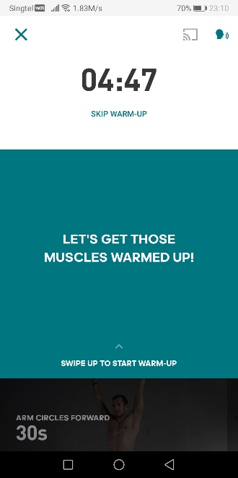
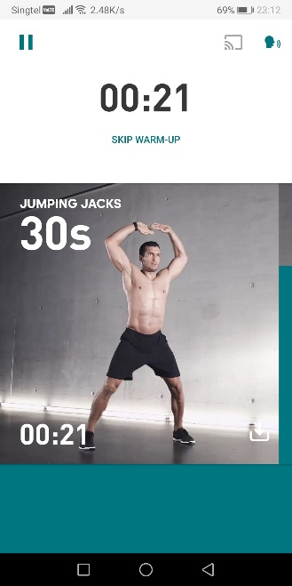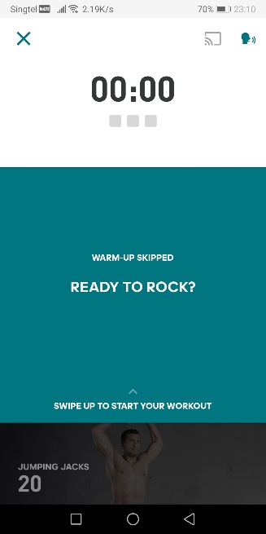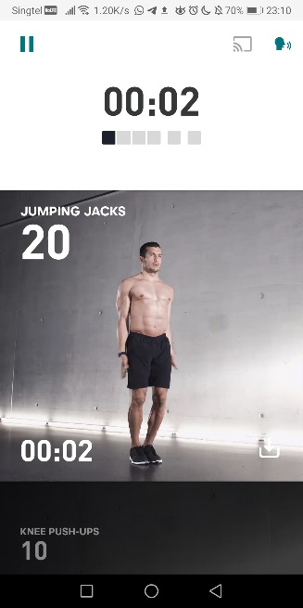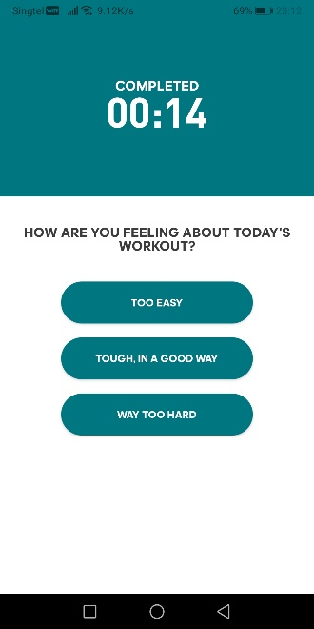
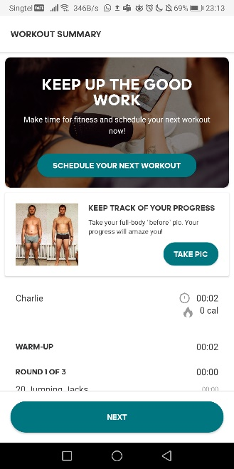
Analysis on workout
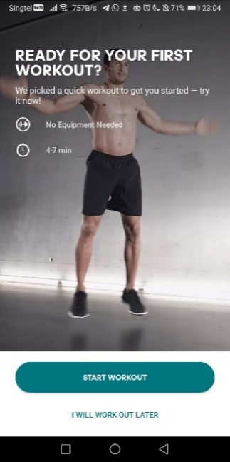
The first screen asks the user of they are ready for their first workout in bold text. Below shows the required time and equipment for the workout. The background of a fit person doing the workout helps to promote the image of fitness to the user. Almost telling the user that they can look like that as well once they get started. The button “START WORKOUT” is highlighted and “WORKOUT LATER” is text uses the similar principle found in the onboarding process.

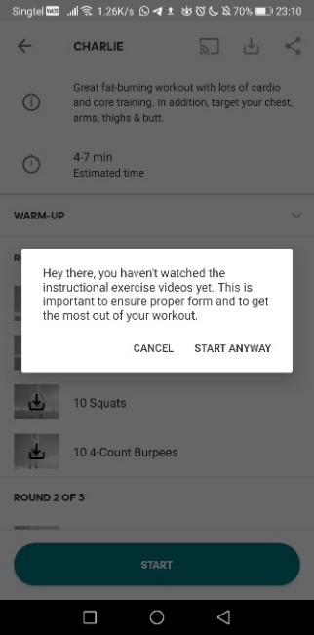
After tapping “START WORKOUT”, users are prompted to download the instructional videos for accurate coaching/instructions on how to perform each exercise properly. This pop up is consistent throughout the app and can be skipped. While this is useful, it looks and feels very out of place as the theme of the app is non existent in this UI element.
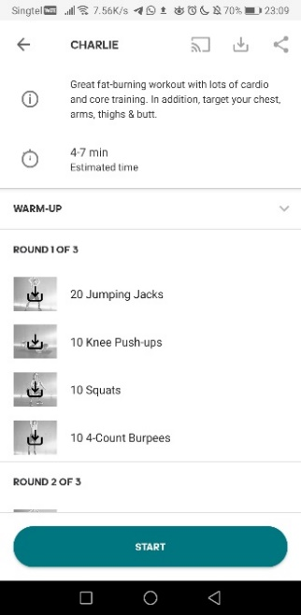
The next screen shows the entire breakdown of the workout, a short summary of the workout and the time needed. The workout is broken into sections for easy understanding and if the instructional video is not downloaded the picture is greyed out with a download icon over it to prompt the user again. It also includes casting, downloading the entire workout and sharing the workout at the top but are greyed out as these are not important.

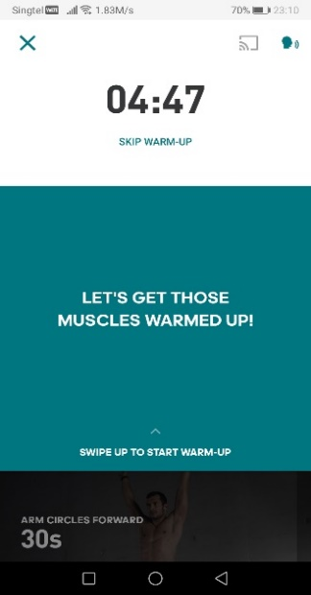
Once started, the user is brought to the warmup section with a huge timer at the top indicating how long it will take. You can also skip the warm-up using the text button below. Huge middle section with a motivational message to get the user into the zone and a swipe up gesture to start the warmup.

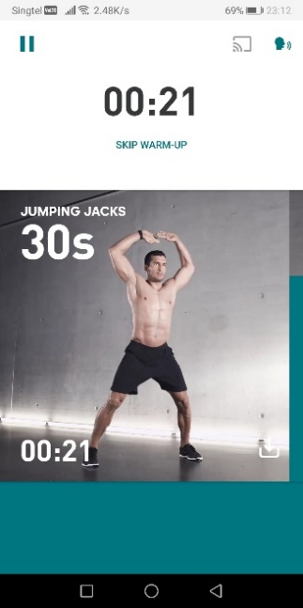
In the warmup section, there is a gif of the exercise along with the name and duration of that exercise. The countdown timer at the bottom shows how much time is left to completion, along with a green progress bar that depletes accordingly. The progress bar feels unnecessary as it is a repeat of the timer in bar form. To indicate the end of the section, the bottom is filled with a huge green box. It would have been better if they had placed the text “Workout round 1” or showed a cut off image of the next section like the image above because users might think that this is the end of the whole workout.

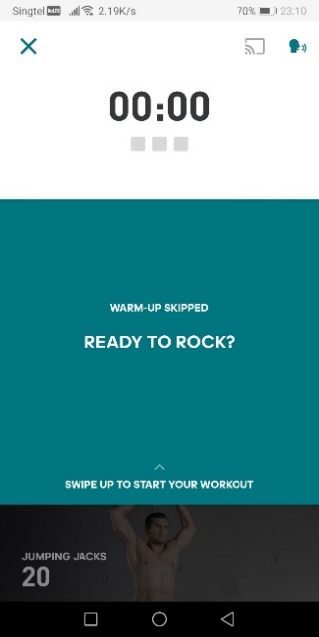
Moving to the actual workout, a timer is shown with 3 grey boxes below it to tell the user there are 3 parts to the workout. The motivational message is shown again and the swipe up to start is there.

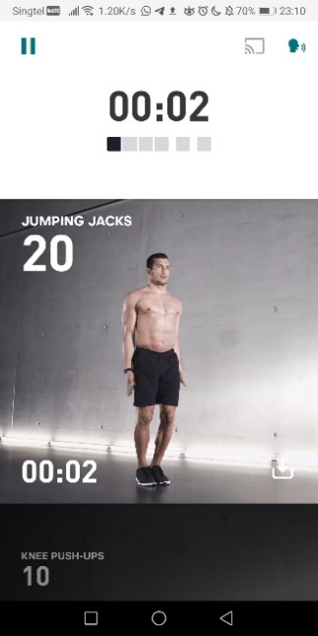
Starting the workout, the grey boxes are displayed with 4 together and 2 other boxes separate to indicate this section has 4 exercises to be done. The same format as the warmup is shown, except they removed the green progress bar at the side.

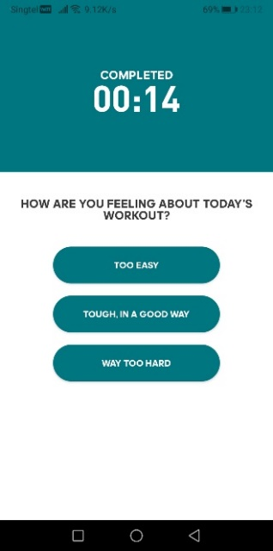
On completion, it shows the total time of the workout as well as a short survey on how the user felt about the workout. The button selection is inconsistent to the previous multiple-choice menu seen in the onboarding process.
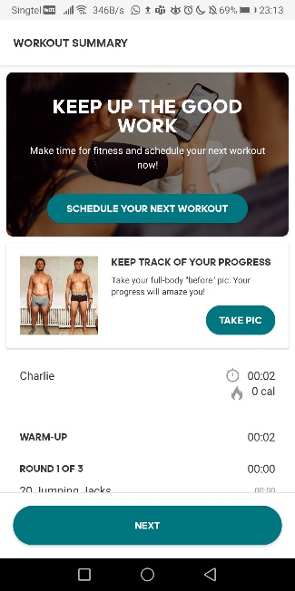
After rating the workout, user is brought to a summary page that shows the breakdown of how the user has done. They also use a huge section at the top to prompt the user to keep using the app by asking them to schedule the next workout with a picture of people using a phone. It also suggests the user to take a picture of their body to keep track, using a transformation picture to enforce the idea that using the app will get the user the fit body they want.

Ritual Anywhere Application
Ritual Anywhere aims to promote high intensity workouts that utilises free weights and bodyweight movements to help individuals get fitter. With a variety of difficulties it allows users from different fitness levels to use the app. The app makes use of mainly stepwise navigation models for most of the processes as this is useful to prevent users from getting lost while navigating through the menu. Consistent colours of black and red coupled with minimal yet sharp edge shapes give it a serious dark tone, it is enhanced by the brand and logo where it seems like the user is about to join a dark workout cult. While this may be appealing for hardcore fitness enthusiasts, it is not as welcoming/friendly compared to adidas and this may put off beginners of fitness.
This analysis will focus on the onboarding process, login, customising, train page, library and workout.
Onboarding
The onboarding process would have been better if helped the user login right after registering rather than forcing the user back to the start with a small login button hidden at the bottom of the screen.
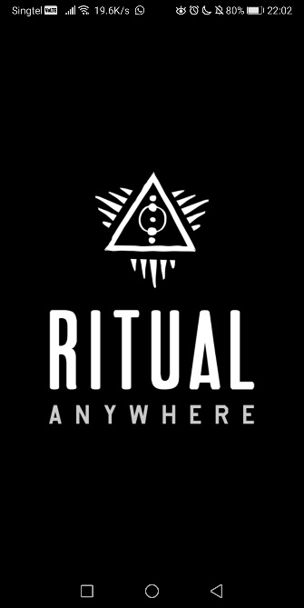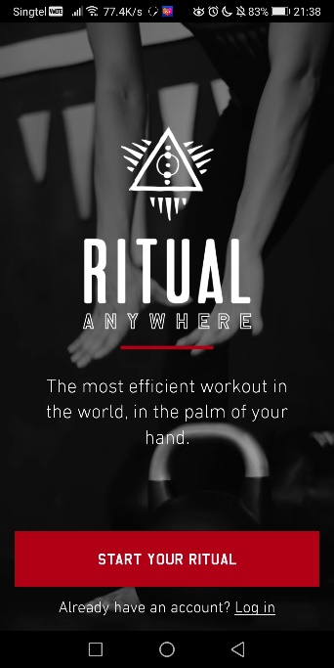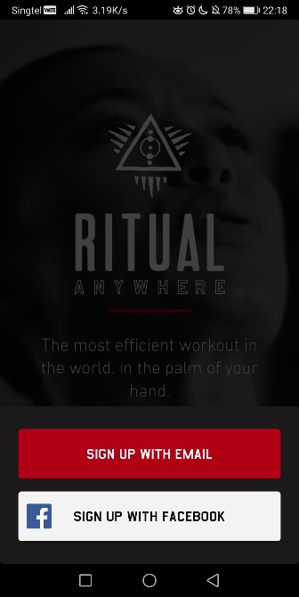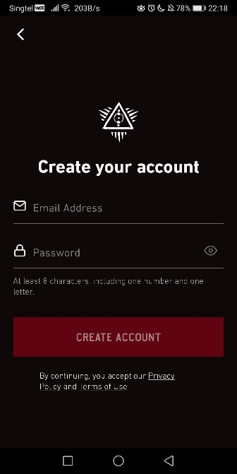
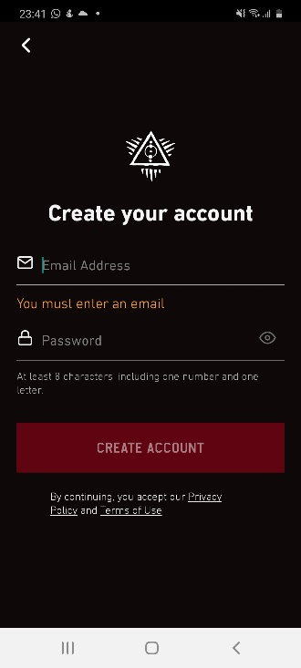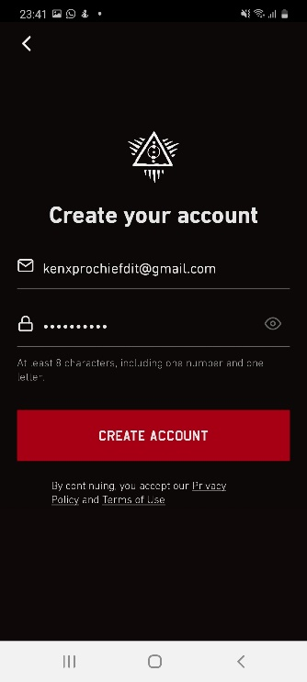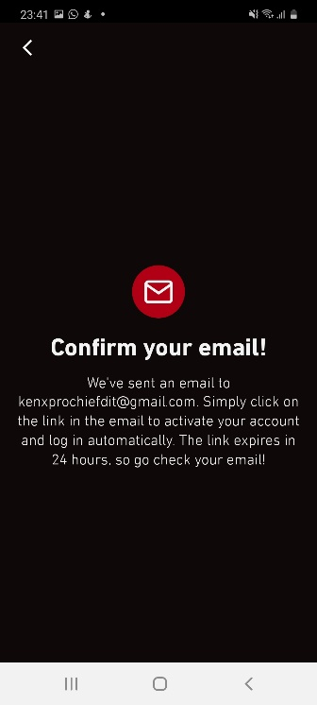
Analysis on onboarding
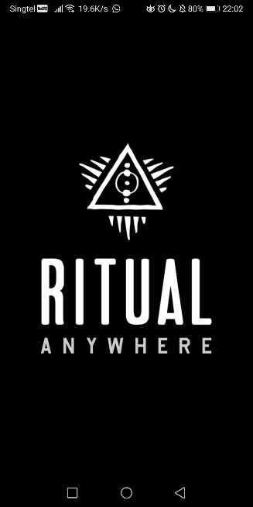
Starting up the app, it shows a huge logo with black background to catch attention of the user. Like the adidas app.

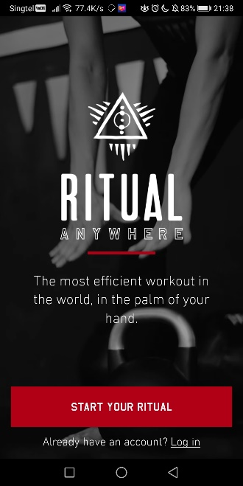
Registration/login screen, the picture behind works well to lead the user’s eyes to the logo as emphasis although the font choice and contrast works against each other here. Greeted with a huge red button that says, “Start your ritual” and a small text button to login. Choice of words make it seem like the user is joining a fitness cult.

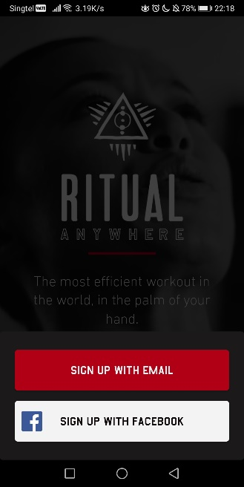
A pop up shows the sign-up options, the background is greyed out and the huge red button is there again.
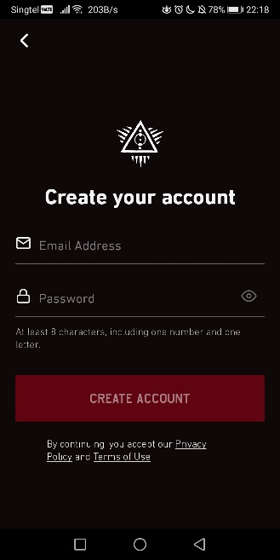
Registration has a much lower cognitive load compared to the adidas app where they require you to fill up a lot of fields in one page. This one only requires two fields. Once again, the logo is present on the screen to help reinforce branding. The “Create account” button is disabled so users are unable to accidentally prompt error messages.

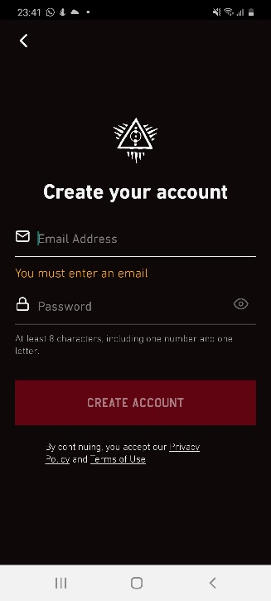
While it prevented prompting error messages with the disabled button, the app shows one orange error message the moment the user attempts to fill in a field. It is constantly there until the user is done filling it up properly. The same thing happens for the password field. Breaks the experience because the it feels like the user has already made a mistake from the start.

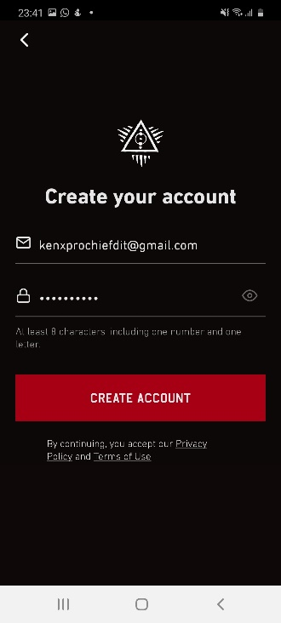
Filling up all fields properly enables the “Create account” button. Transition is very noticeable which is good for user navigation.
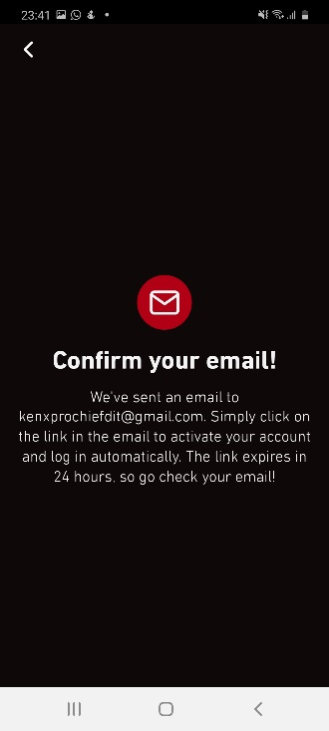
The user is brought to a confirmation page with no buttons, except the back button which has been visible in previous screens. Tapping on the screen does nothing. The back button brings the user back to the login/register page. This breaks the flow of the user as there is no immediate way to proceed from here. Including a login button would have made it a lot smoother.

LOGIN
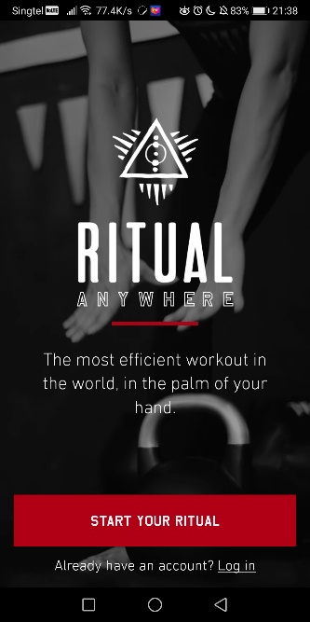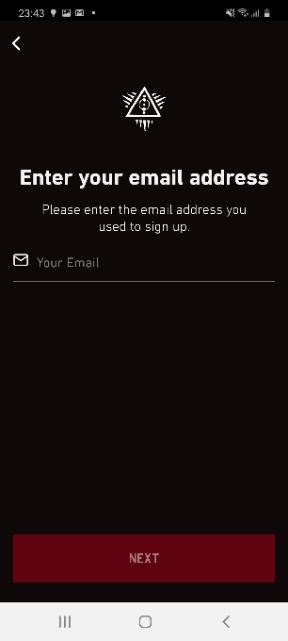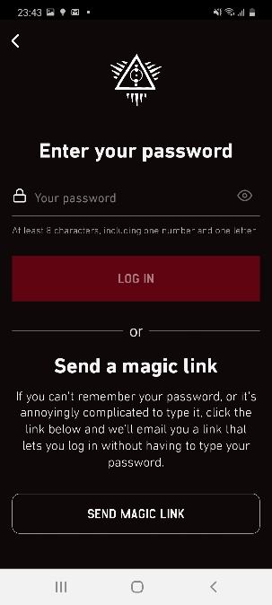
Analysis on login
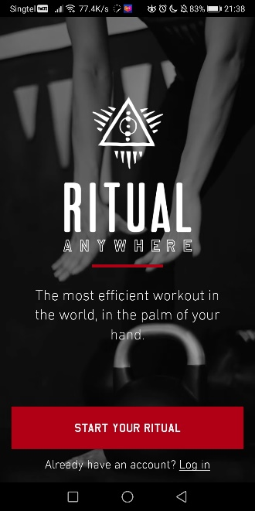
After returning to register/login screen, the login button is a tiny text button at the bottom. If would be better if the switched the register button to login instead.
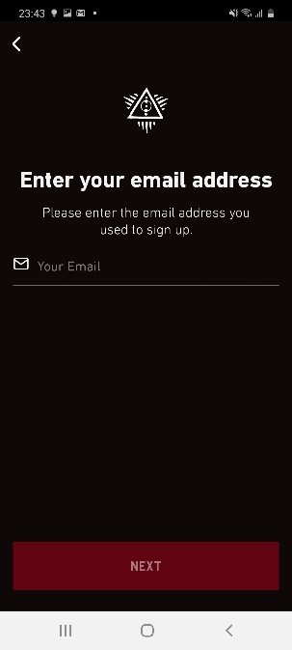
Login page, low cognitive load again. Huge bold text to tell user what to do here. Only requires email input. The same theme of disabling the button can seen as well as the logo. This time it does not have an error message once the user taps on the field.

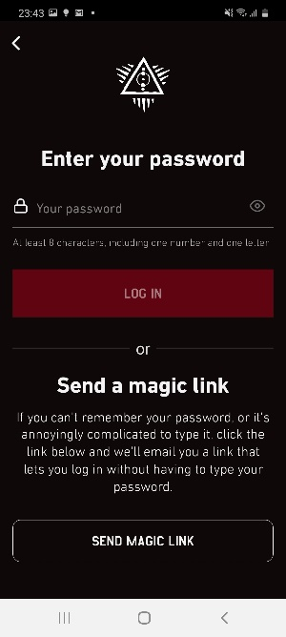
Password input page, with huge bold text again. This time the logo is larger, maybe to show progress. The bottom half is really confusing for a simple “Forgot Password” button. Using unconventional text and then proceeds to write an entire paragraph explaining what “magic link” means.

Customising
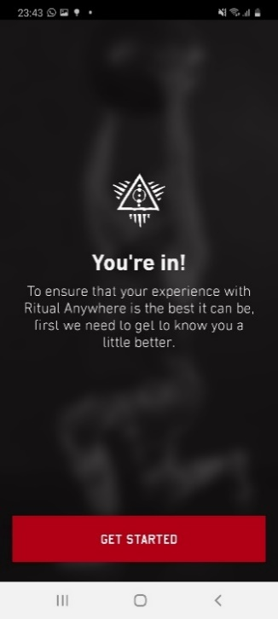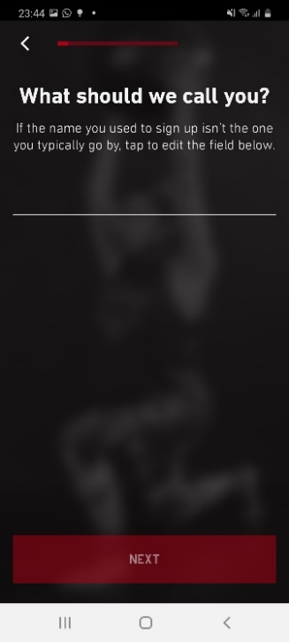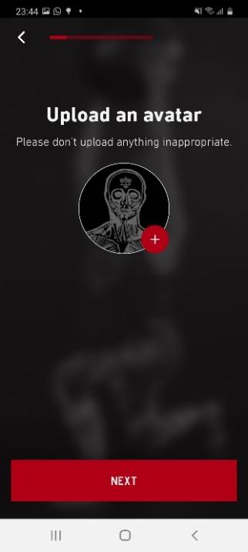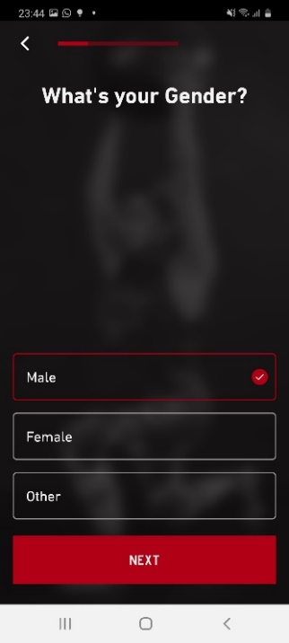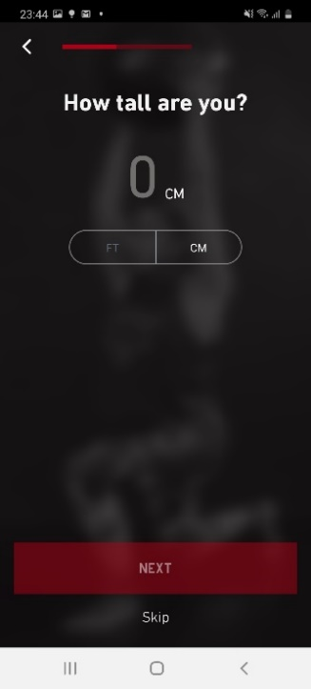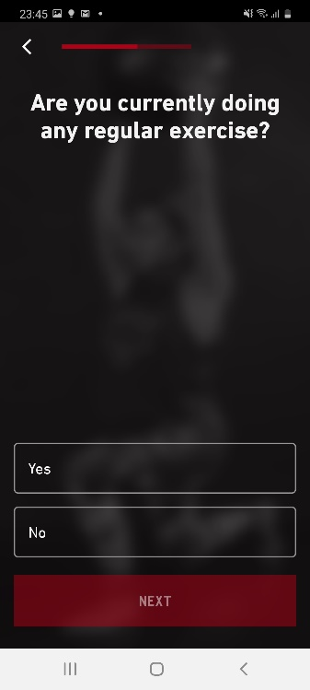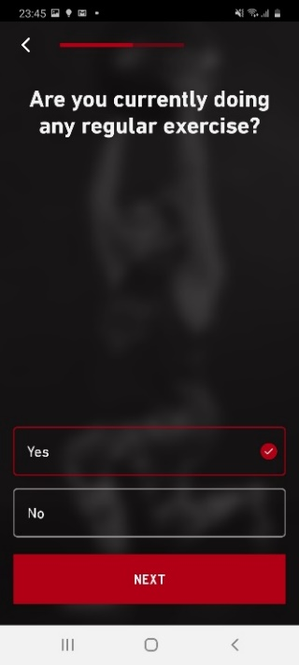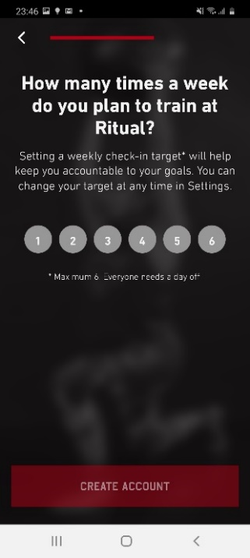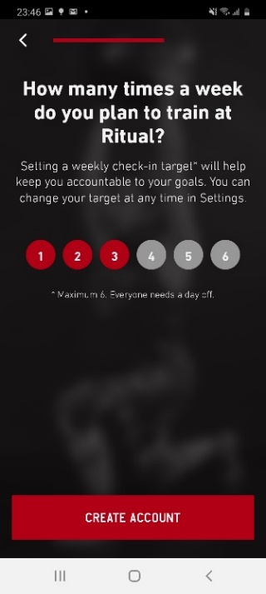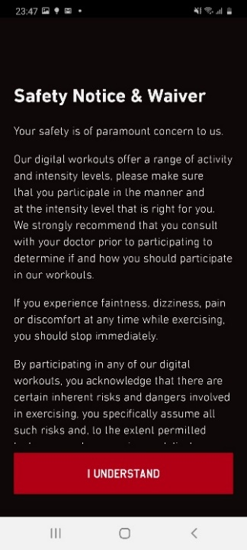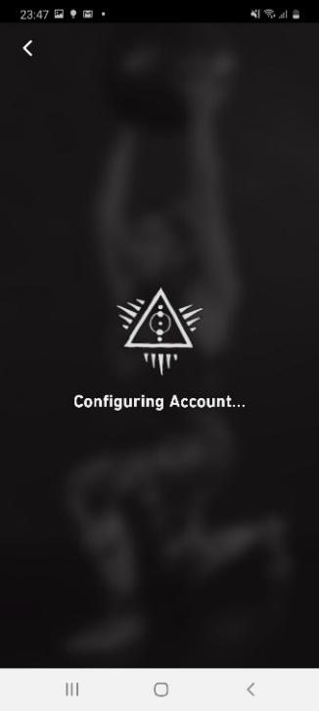
Analysis on Customizing
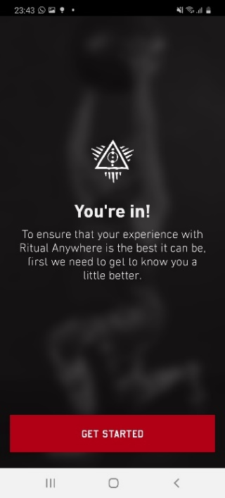
Upon first time login, user is greeted with a welcome page and introduces the customizing survey. Logo is seen again, this time with a blurred-out image at the back. This indicates to the user that they are almost done and can unlock the exercises soon. The huge red again is consistent with other screens.

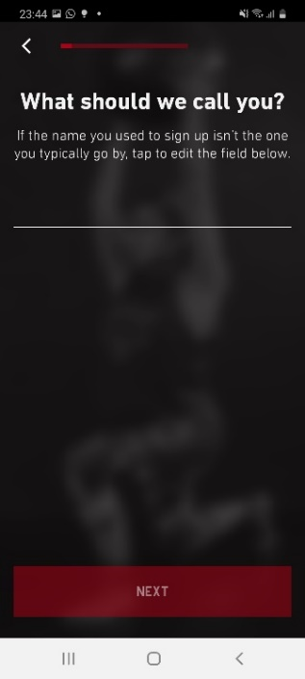
On starting survey, there is a tiny red progress bar like adidas with a back button beside it. Huge white text asking a question, which is easy to understand, and the red button is disabled. It would have been better if they did not include a bar or any indicator at all, at first glance it looks like there are a lot of things to fill up based on the current progress of the bar compared to adidas where it was already 1/3 filled on the first screen. It can be put off potential customers.

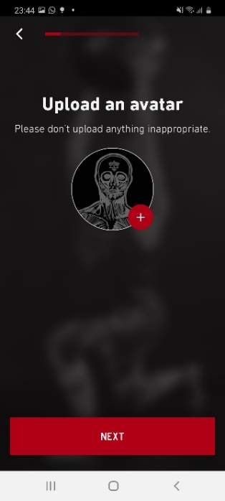
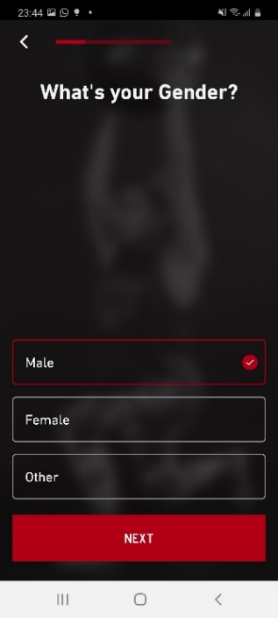
Simple upload of user avatar, the template avatar looks like a slightly satanic person with the logo branded on the forehead. It could work if the user is looking to be part of cultists or it could make users quit the app in fear that they will be brainwashed.
Gender selection screen provides similar layout; it introduces multiple choice, upon selection highlights the box in red and a red check mark. The red highlight does not work so well because it is too dark and almost blends in with the background. They could have used the same shade as the huge red button or checkmark.
Another thing they did was include “Other” as an option, which can hint to users that the app is inclusive, although it could also put off some users that dislike “progressiveness”.

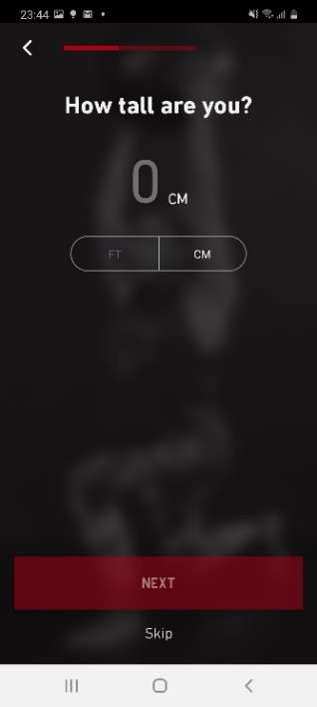
Height and weight selection are the same. Both have the option to be skipped with the small text button below the disabled “NEXT”. While it may feel welcoming, it does not help the user to reach the goal they want. It almost gives the message that weight does not matter. It is good that they provide both metric and imperial units of measurement, catering to different regions.

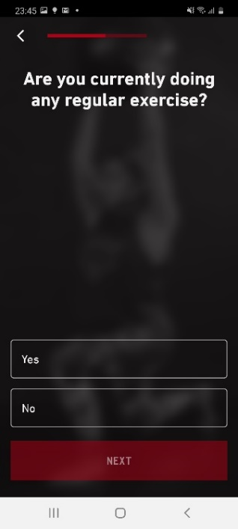
Multiple choice question with the same layout as the gender selection screen.

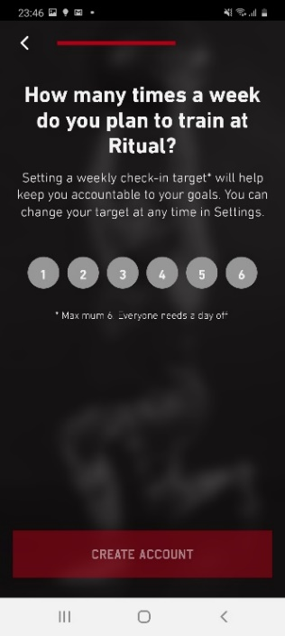
A different layout when asking about days of training. The buttons do not fit the overall theme at all. Grey circles with off centre numbers give a tacky feel and breaks the experience for users. It would have been a better flow if they stuck to the multiple-choice layout from previous screens.
While it is nice touch is the text change for the huge red button from “Next” to “Create account”. It can be confusing to users as they have already created an account before logging in. Is this another account?

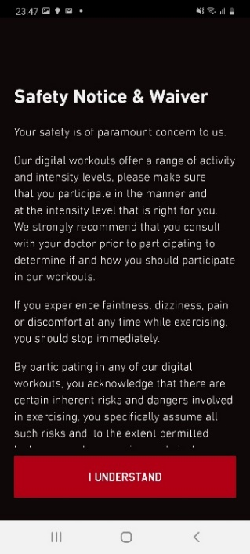
Safety notice page, simple title and scrollable text screen with huge red button below.

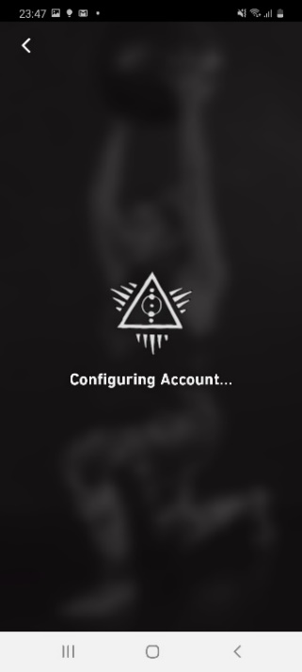
Loading screen with the logo and configuring account text, emphasis on branding again.
Train (Hub & Spoke)
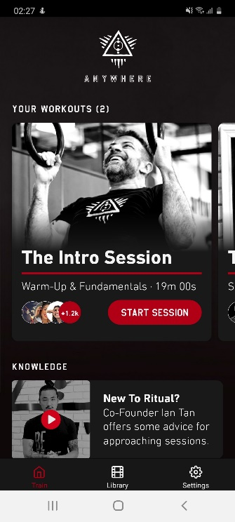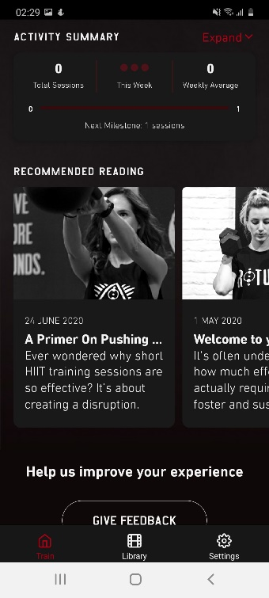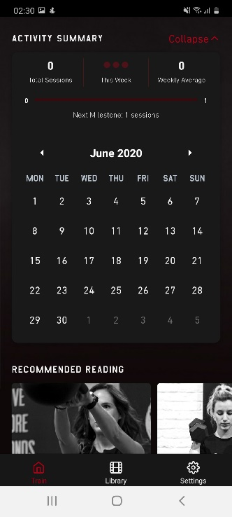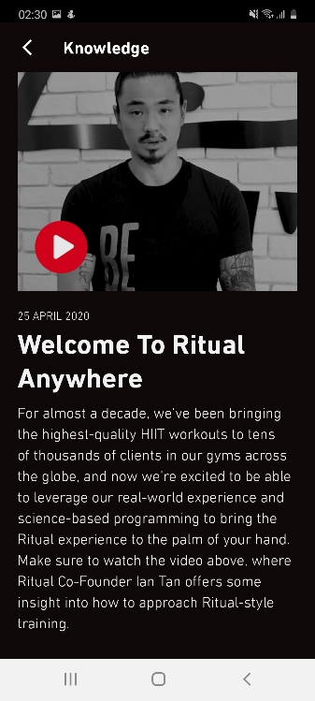
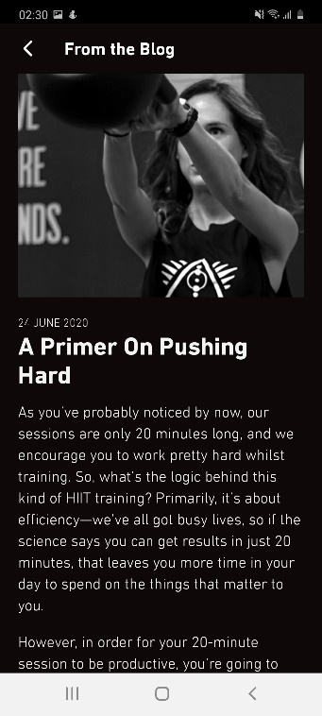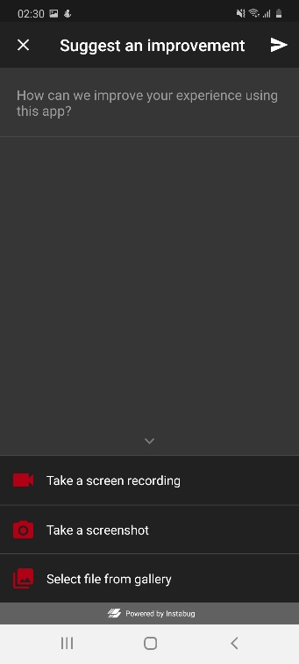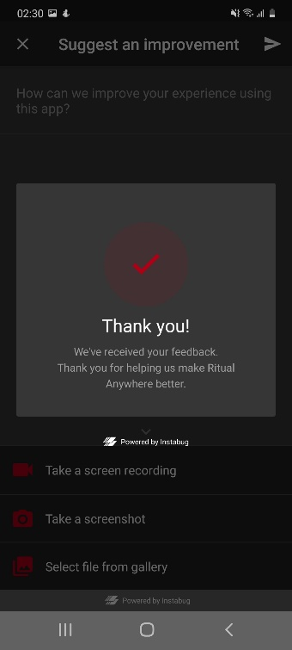

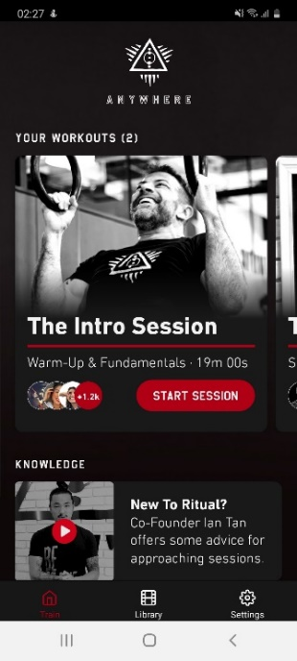
Analysis on Train page
The “Train” tab would consider this the main page based on the tabs located at the bottom of the screen. The tab bar at the bottom is always visible on this screen regardless of scrolling up or down.
Logo is at the top again. Huge space given to the workout section to draw user attention with the picture of the man looking at “Your workouts” and smiling, it gives the user the feeling that they will be happy as well. “The Intro Session” is big and easy to understand. It is good that they provided the number of people currently doing the session on the bottom left of the square, so the user knows that they are not alone.
Below we can see the knowledge section that only has 1 element which is just a button that brings you to a video page with some text. It feels like an unnecessary usage of space when it could have just been hidden at the bottom or placed inside the “workout” process.

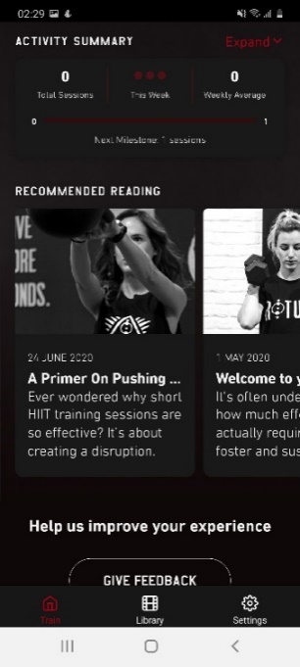
Second half of the “Train” tab includes activity summary, giving a brief overview of total sessions, dots to indicate how many workouts to be done this week which could be replaced with numbers and the weekly average. It also includes next milestone with a progress bar from 0 to 1, weird choice because the progression is either yes or no.
Recommended reading section are news articles on fitness which takes up the same vertical space as the workouts section. The width is smaller because it is less important.
At the very bottom is a rounded feedback button which breaks from the theme, they could have used the same squarish red button seen on the other screens.

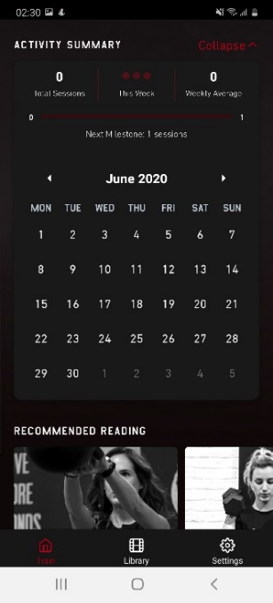
Pressing on the “expand” button shows a calendar to indicate planned workout sessions which is a nice touch for users to plan their workouts accordingly. Text colour could have been brighter as it seems to blend in too much right now.
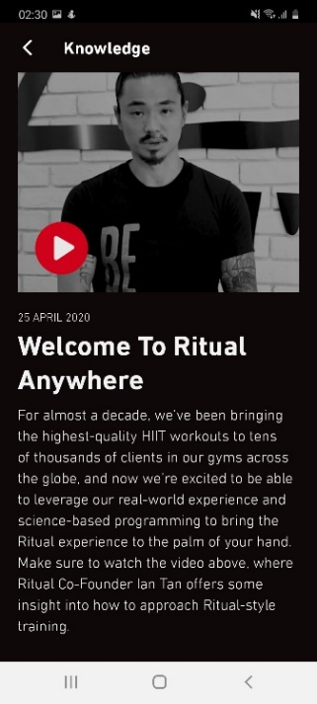
Tapping on the button at the knowledge section brings you to a page with a video and summary text at the bottom. There is only a back button at the top left. Thumbnail looks serious with the greyscale image, professional looking.

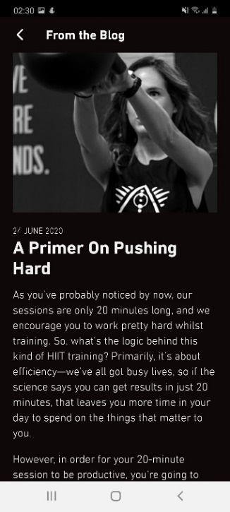
Tapping on any recommended reading button leads to a page with the same layout as knowledge.

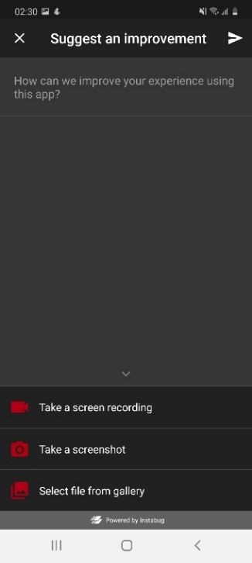
Tapping on “Give Feedback” button brings a pop-up screen with simple layout of text field and additional attachment options at the bottom.

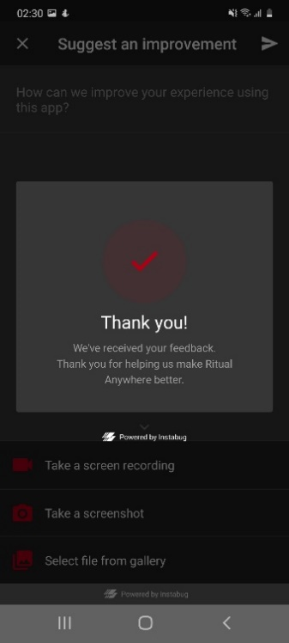
Completing the feedback brings up a thank you pop up with a checkmark logo that is inconsistent with previous checkmarks seen in the app. Might be due to the feedback system being powered by a 3rd party software.

Library (Hub & Spoke)
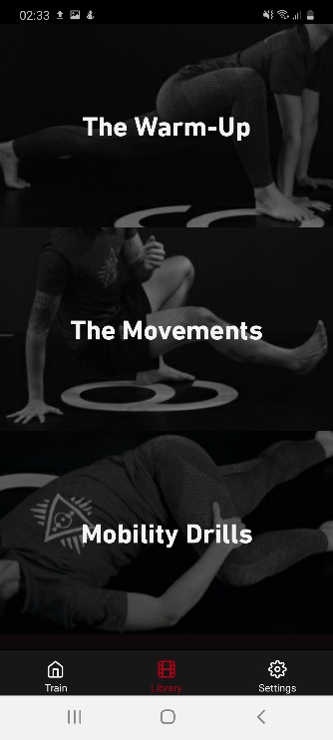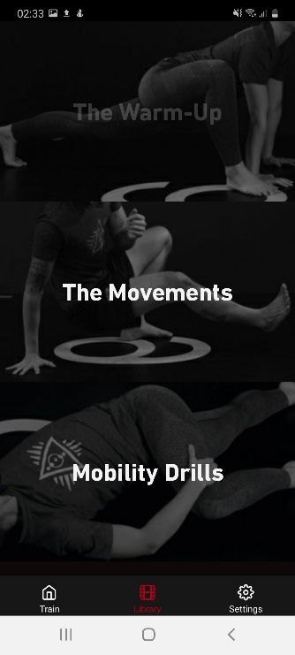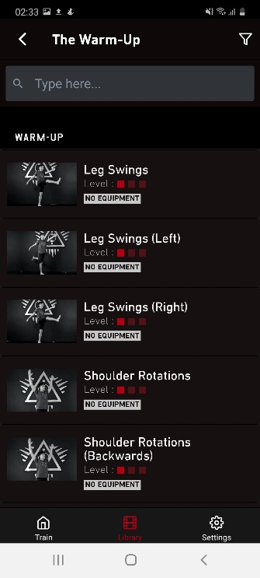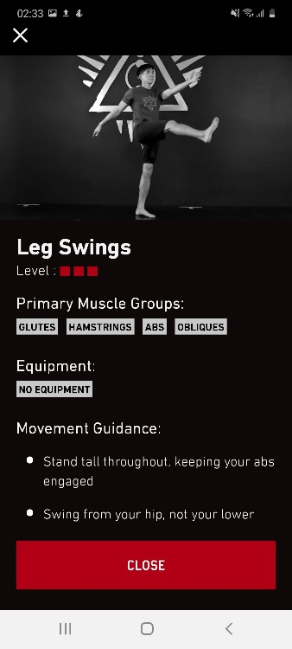
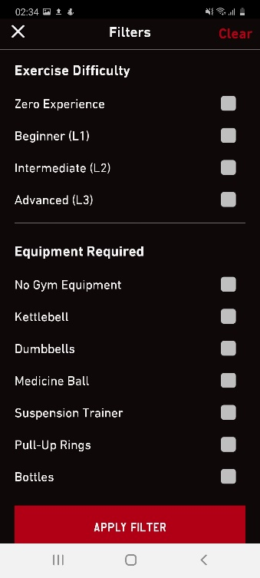
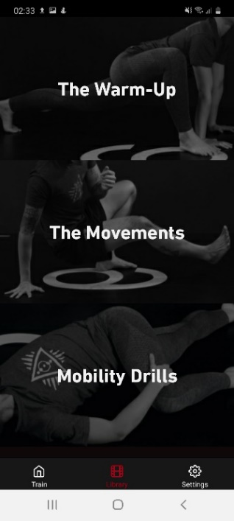
Analysis on Library
The library page has the same tab bar located at the bottom of the screen. This page has only 3 buttons that consists of all exercises that are used within the app. The pictures follow the words chosen properly, gives the user a brief understanding of each category.

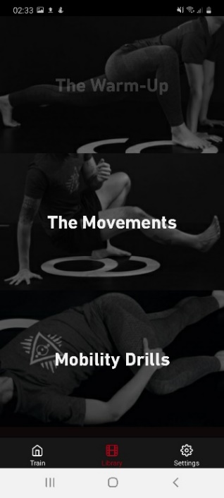
On tapping on any of the buttons, the button is greyed out. This is one of the few buttons highlighted feedbacks seen in the app. It stands out, they should have removed it to provide a more consistent experience.

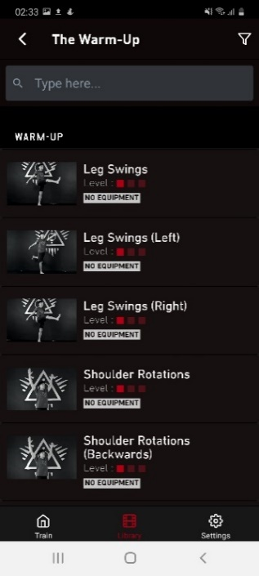
All three buttons on the previous screen brings you to the same layout. The exercises are displayed in rectangles that show the name, difficulty level and equipment required. Users can also choose to filter or search for a specific exercise.
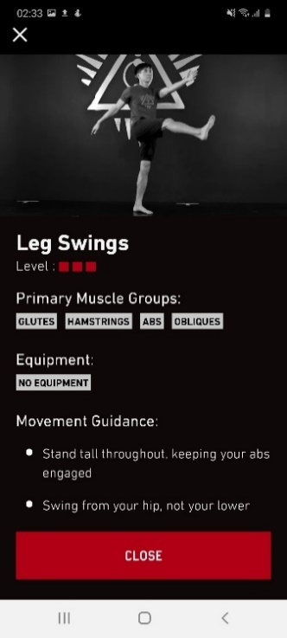
Tapping on any exercise brings a pop up that you can close with the cross button and a huge “Close” button at the bottom of the screen. Confusing change of theme and layout. Keeping to the same back button would have worked better as it is consistent.
The difficulty level shown on the previous page also seems to be different from this page. This misinformation can also be seen in other exercises.
The light grey rectangles with words are not buttons. They look like buttons, yet they do not do anything. Would have been better to just leave them as text without the boxes or link it to a page with exercises that include “Glutes” if “Glutes” was pressed.

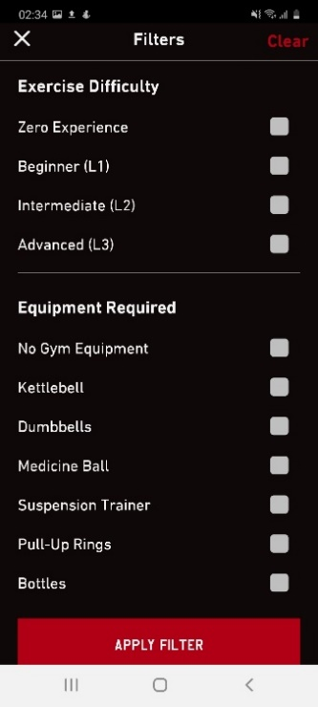
Simple filter page with different categories as options. Huge “apply filter” button to remind users to press it if they want to use the filter function.

Workout (Stepwise)
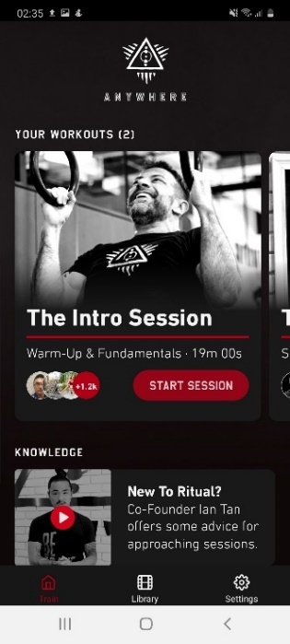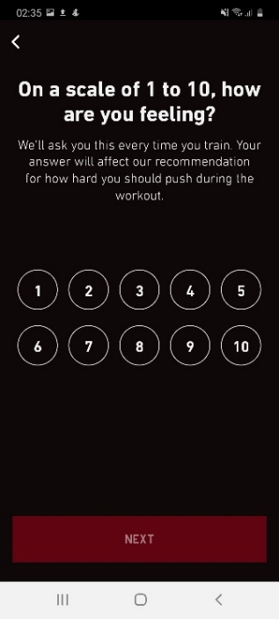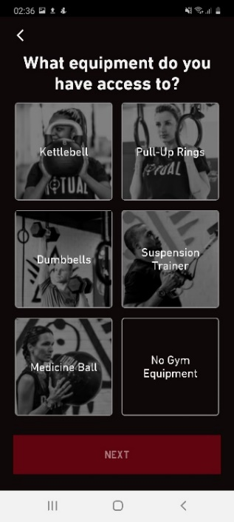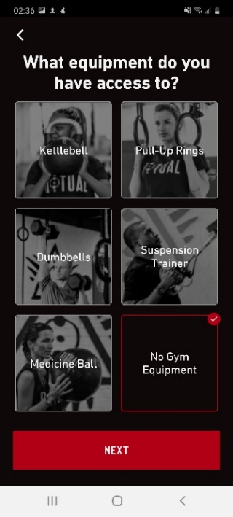
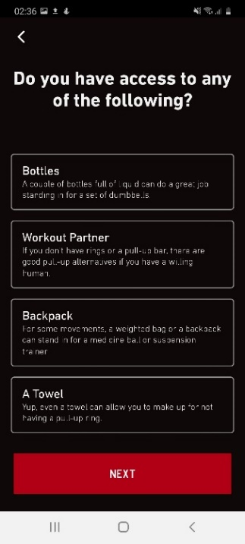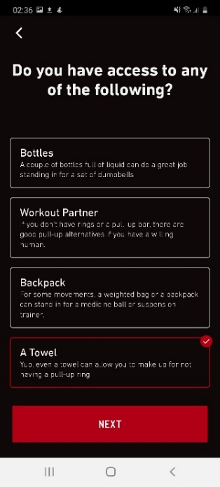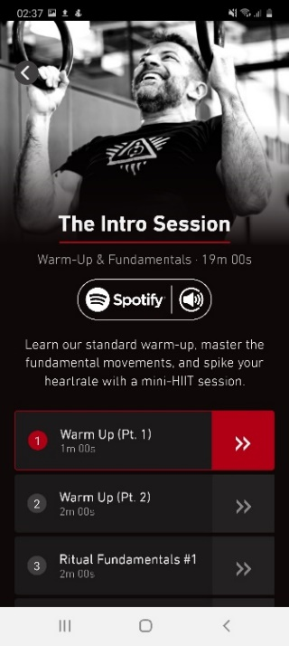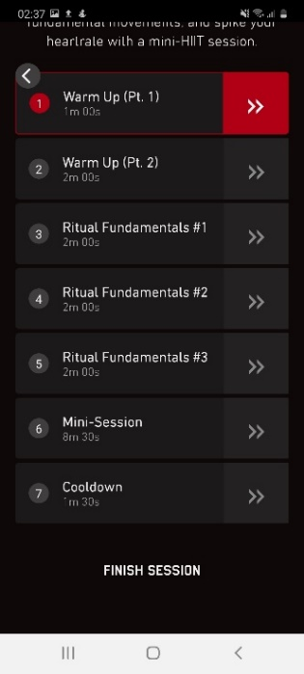
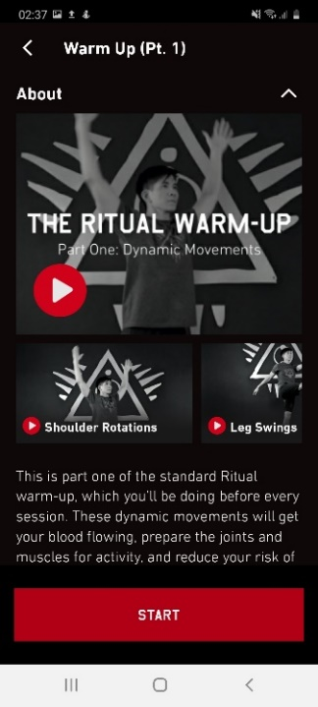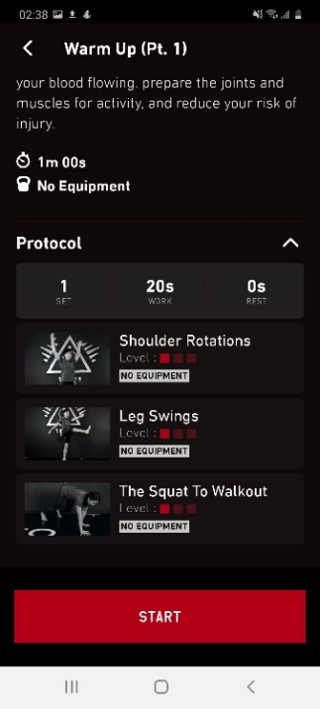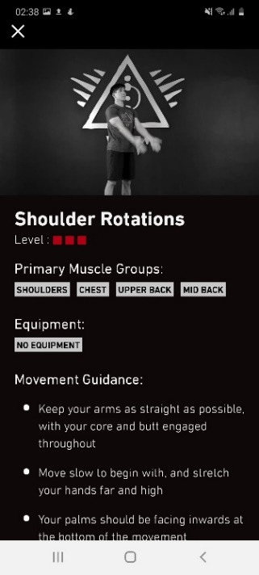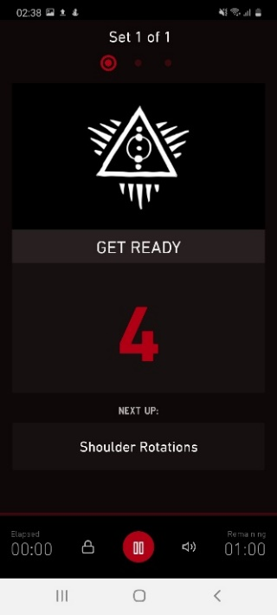
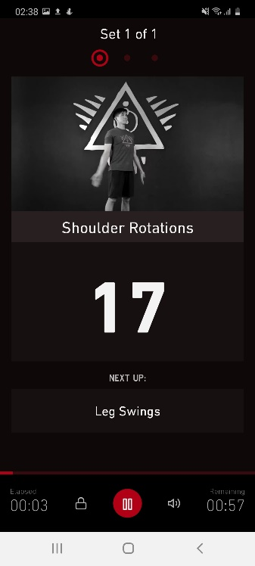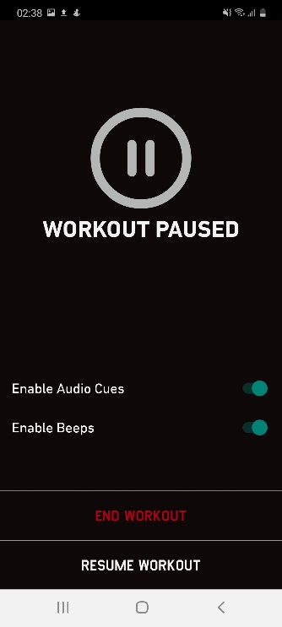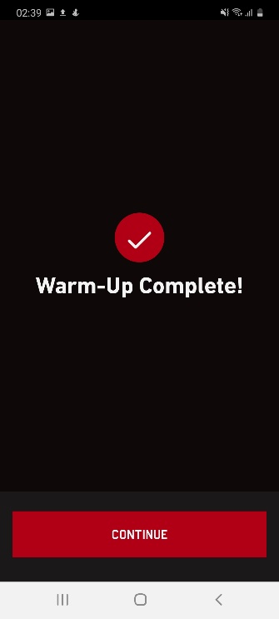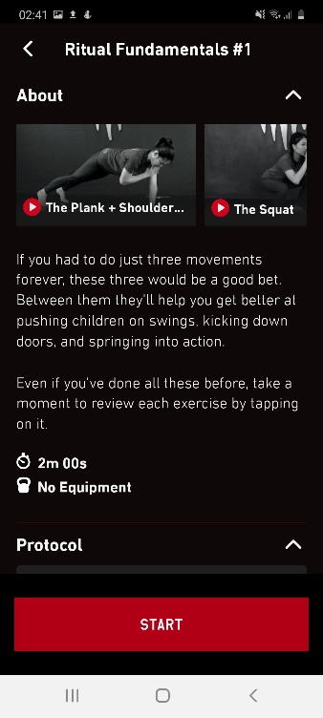
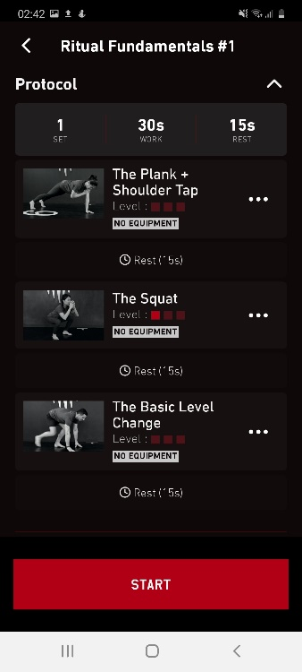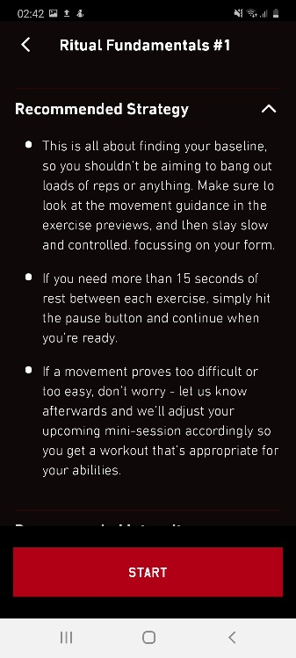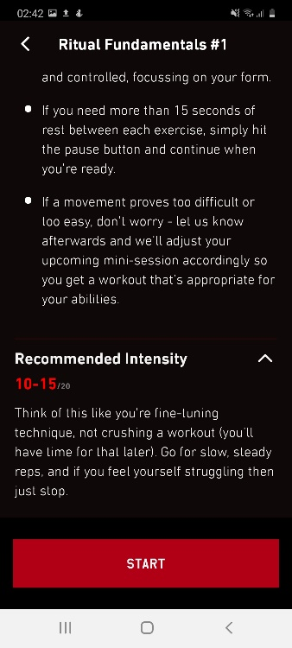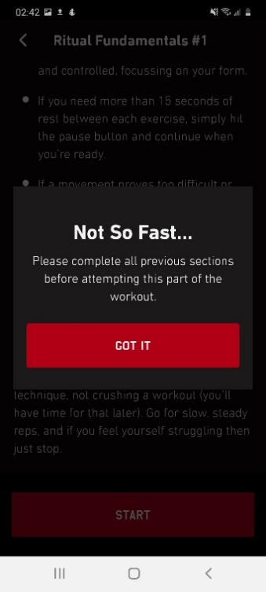
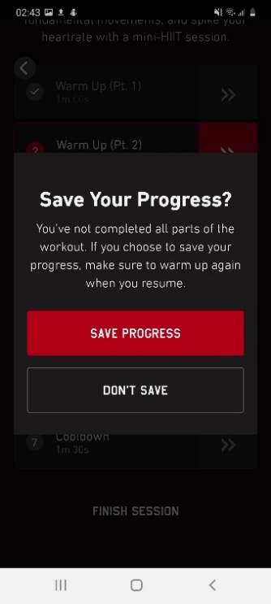
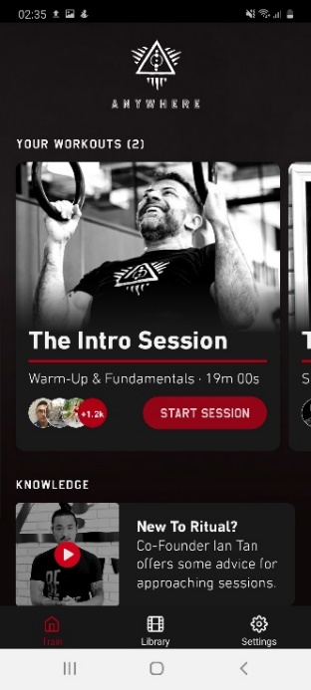
Analysis on Workout
Tapping on “start session” the button has a slight grey out transition before moving to the next page.

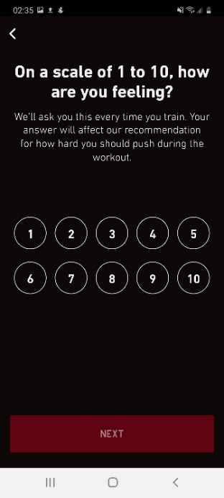
They include a rating survey before starting the workout to help tailor the workout to the user. This is a good touch in terms of user experience, but the button choice breaks from the theme again, the colour is also different from the previous circle buttons seen in the customizing process.

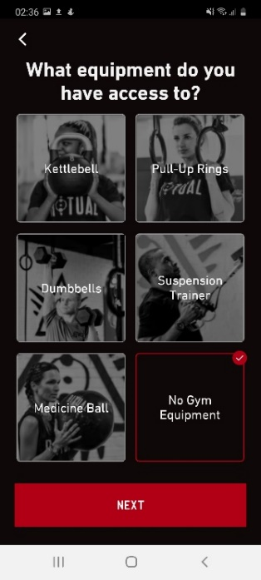
The next page asks you about the equipment you have access to, now they changed the layout again to square buttons with pictures. Maybe it is to help users understand what the words mean. Pressing on any button will highlight it with the same dark red and bright checkmark.
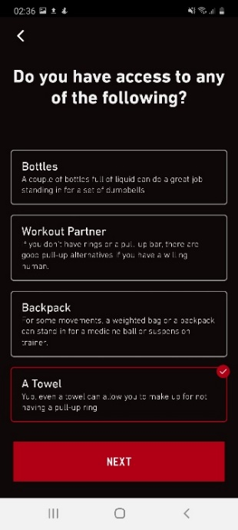
The next screen asks if you have any of the following items, now the layout is changed back again to the first multiple-choice layout seen in the customising process.

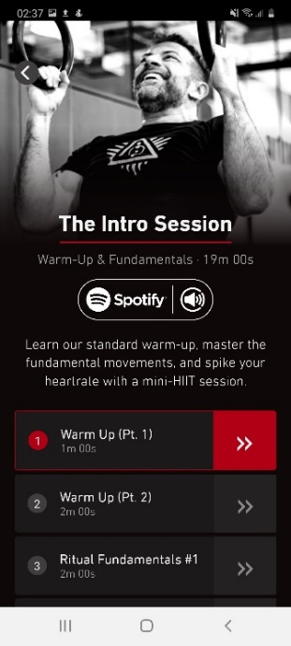
Upon confirming equipment, user is brought to the intro of the workout where it states the amount of time and how many parts the workout has. It also allows users to link their Spotify to the app. The same picture of the man seen in the “Train” page is also shown.
The layout and button style have also changed again. It looks like the user should tap on the arrow button but tapping anywhere on the rectangle works the same. The arrow is also not aligned properly, looks sloppy and breaks experience.
In terms of workout recommendation for beginners, adidas app does a better job with the shorter workout.

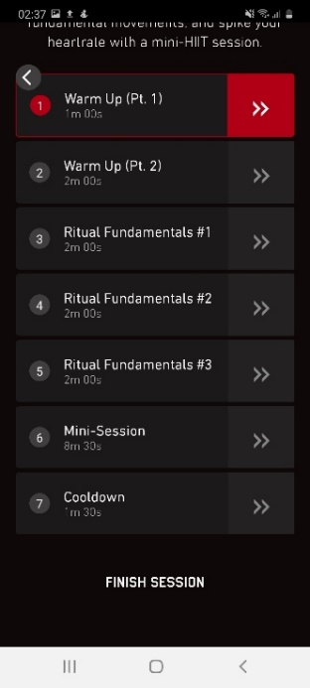
This is the full list of parts to the workout with a text button “Finish session” located at the bottom. It almost feels like a different app at this point with all the different style changes.

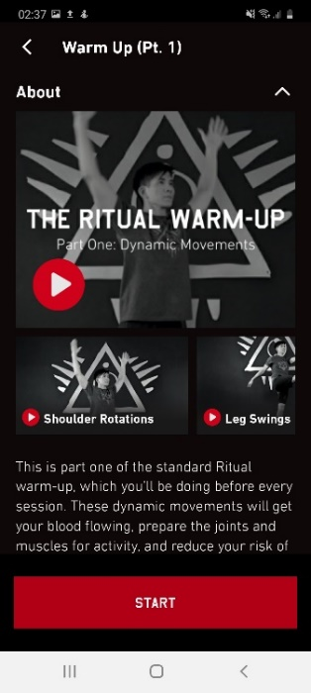
Entering the warmup part 1 page, videos are displayed at the top for users to watch and understand how to do the exercises and a brief summary of what this warmup does. Now the huge red button is back again, it is constantly on the screen.

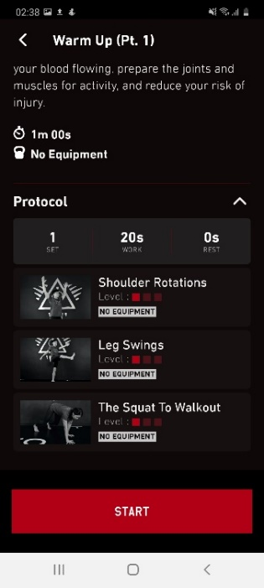
Scrolling down, the user can see the duration and equipment needed. The word choice of “Protocol” is confusing. Putting exercises or movements would have been a lot better. The rectangular buttons that showcase the exercise and difficulty of exercise are the same as seen in the “library” process.

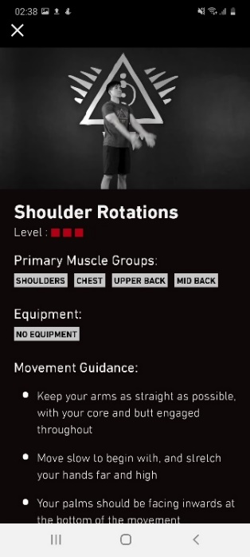
Tapping on any of the exercise brings up the pop up which is the same as the one in the “library” process. Again, the same issues highlighted before are visible here.

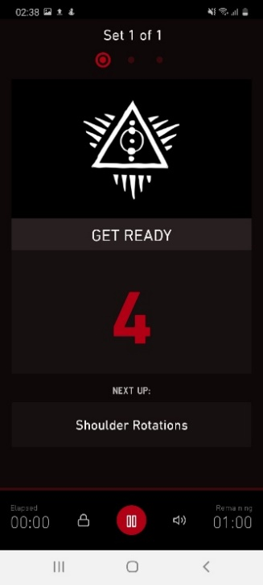
Pressing start brings the user to a count down page before the actual workout with a huge logo, a dark red count down timer, next exercise and a weird music player interface that just pause/resume the timer.
This screen is messy, the logo and the timer are fighting for attention. Why do they need to place the logo here? At this point it seems like the app is very self-centred, borderline egotistical. Having just the timer with a brighter shade for the number would have worked a lot better.

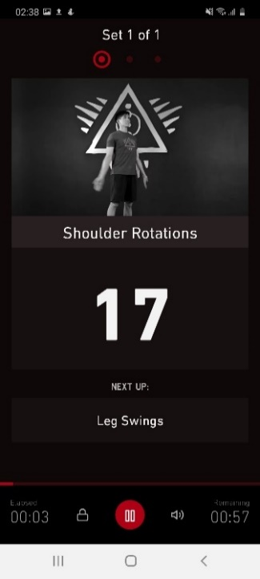
Once the workout starts, you have a video of a man performing the exercise with the logo in the background yet again. This time the count down timer is a lot more visible.

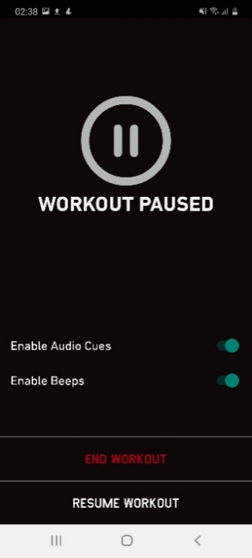
Tapping on the tiny red pause button brings up this pop up with a huge pause logo at the middle that does not do anything. The actual button to resume is located all the way at the bottom.
Resume workout button should have been above instead of end workout. It seems to encourage the user to end it, confusing flow.
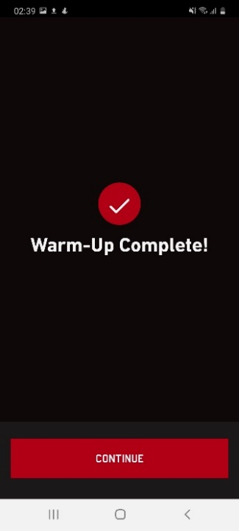
Completing the warmup brings you to a confirmation page with the checkmark.

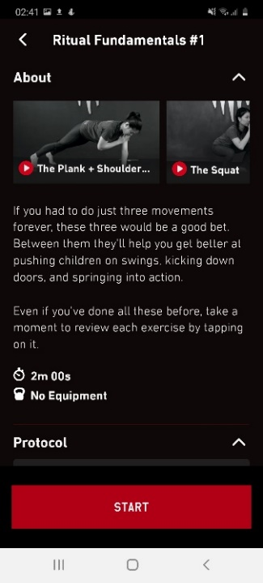
The workout part after the warmup part has the same layout in the top half, with the summary, videos, duration and equipment. Pressing start also leads the user to the same layout as the warmup part.

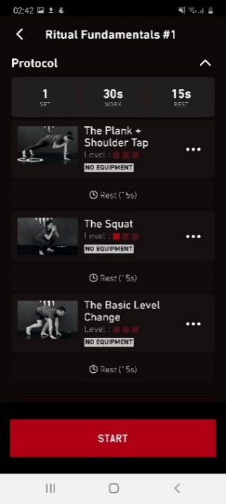
Same layout in the bottom half as well. With the same issues stated earlier.

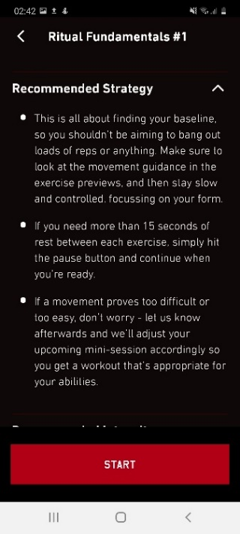
Scrolling down further, there is something new included here that was not in the warmup part 1 page. It shows the recommended way to do the following exercises.
This could have been placed on the next page after tapping on start since users will tend to skip things hidden at the bottom.

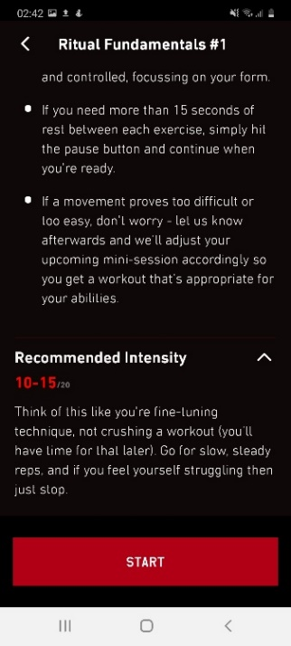
Scrolling down even further brings the user to the recommended intensity for the following exercises. This is actually important information since beginners tend to not understand how hard they need to push themselves during exercise to make it effective.
This could have been placed on the next page after tapping on start since users will tend to skip things hidden at the bottom.

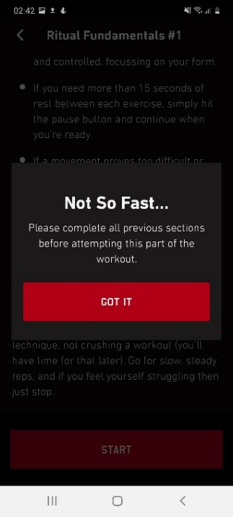
If the user attempts to skip a part, a pop up appears to remind the user to complete all previous parts before attempting. This can be restrictive for some users, while others might find it helpful.
The adidas app does a better job at this since it allows users to skip the warmup part of their workouts.

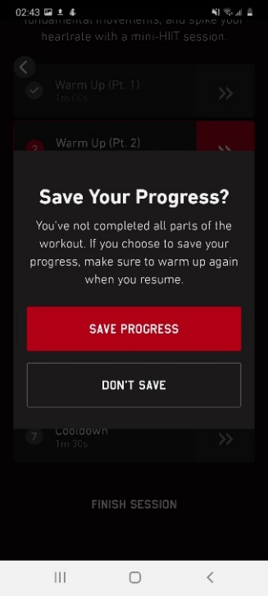
Pressing the finish session brings up a pop up with 2 choices, the style of button changed again. Now instead of text button, there is a white rectangle outline around it.

PUMATRAC Application
PUMATRAC focuses on home workouts that utilises bodyweight movements to help individuals get fitter, from HIIT to dancing and Pilates, the app caters to different forms of exercises so there is something for everyone. The app makes use of mainly stepwise navigation models for most of the processes as this is useful to prevent users from getting lost while navigating through the menu. Consistent colours of majority white with black coupled with minimal yet sharp edge shapes give it an industrial feel that is serious but not dark. It feels like the edgy version of adidas. Less friendly looking and also the only app out of the 3 that has a shop page to promote its products.
This analysis will focus on the onboarding process, customising and workout.
Onboarding
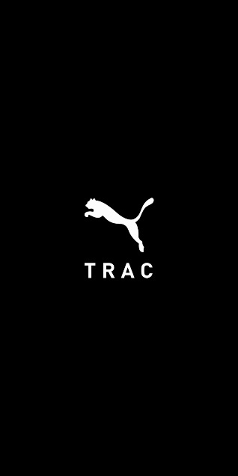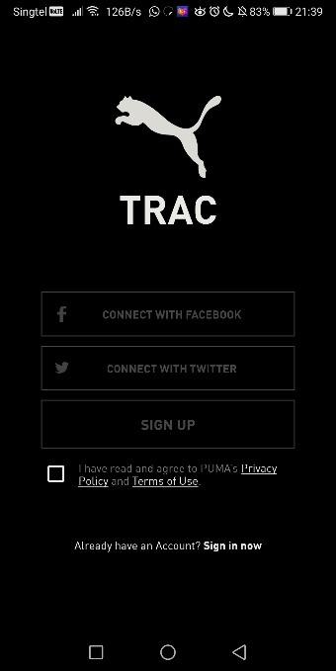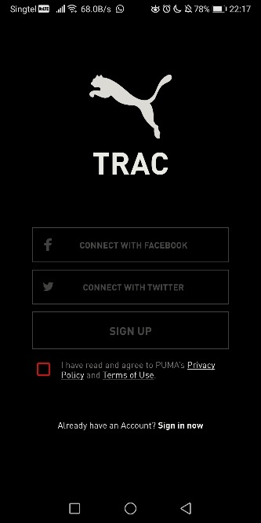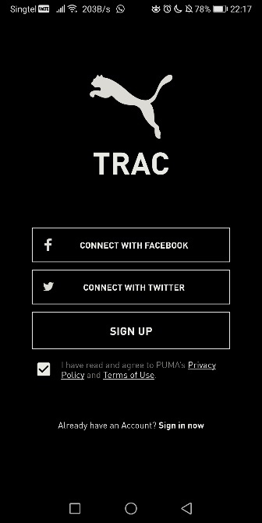
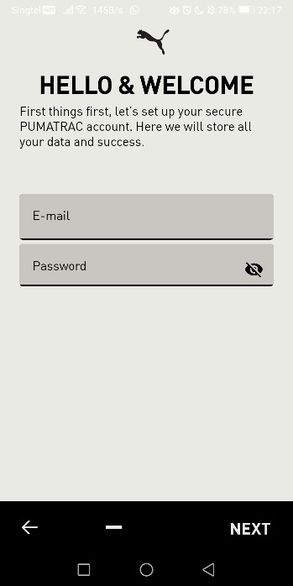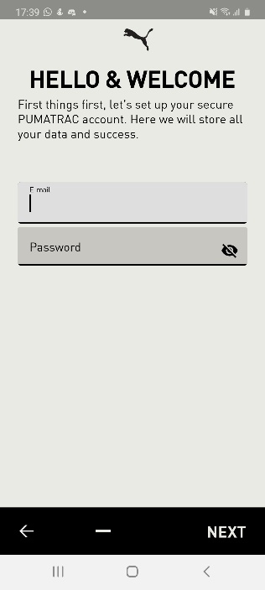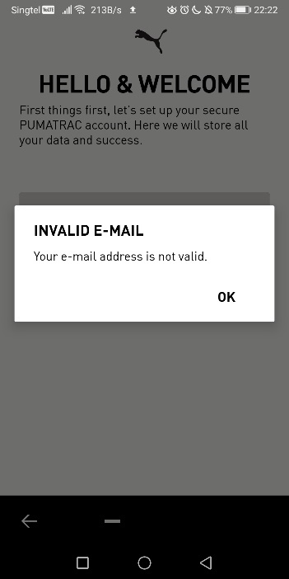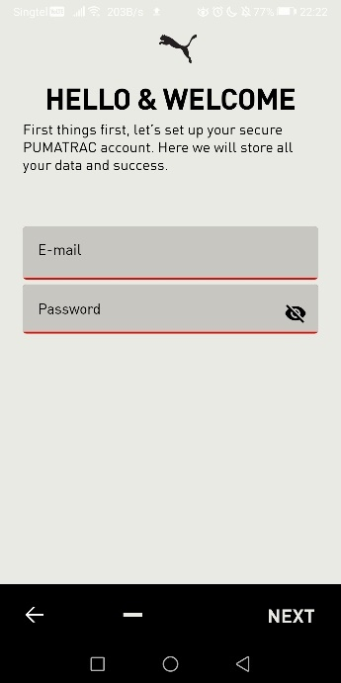
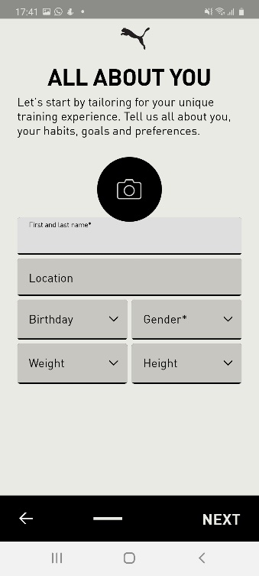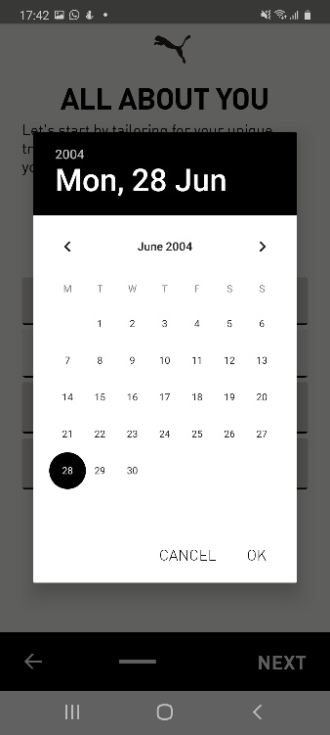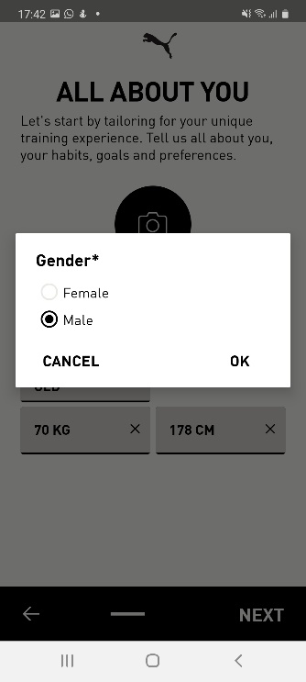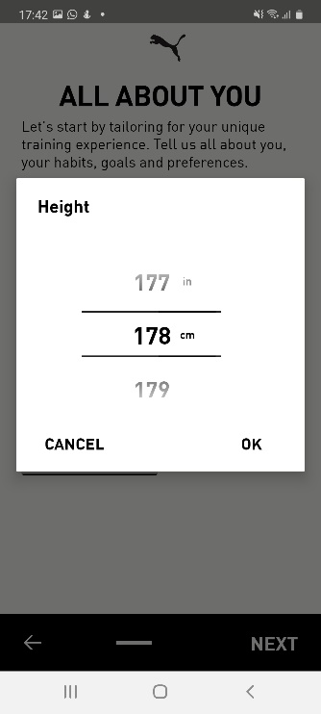
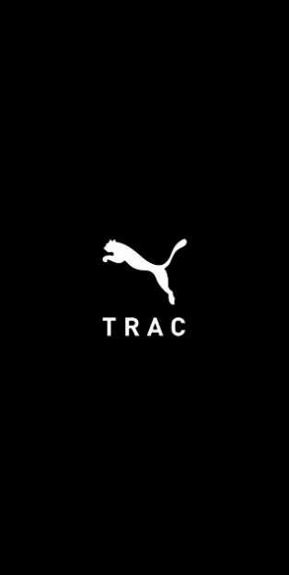
Analysis on onboarding
On start, the logo is flashed with a black background. Looks professional with the clean font and logo.

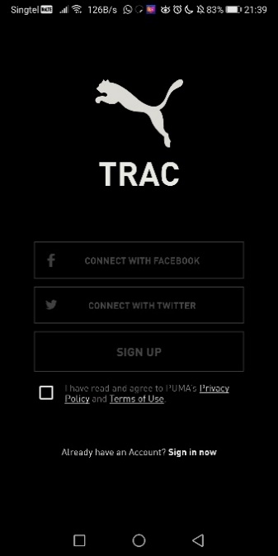
Register/ login screen has the logo in huge contrast with the background, this works well as there is nothing to distract the user. All buttons are disabled to allow the user to focus on the terms and conditions checkbox.

Attempting to press on any button will highlight the terms and conditions checkbox with a red outline to prompt the user that this is required to proceed. The login button is so small, which is the same issue that the Ritual app has.

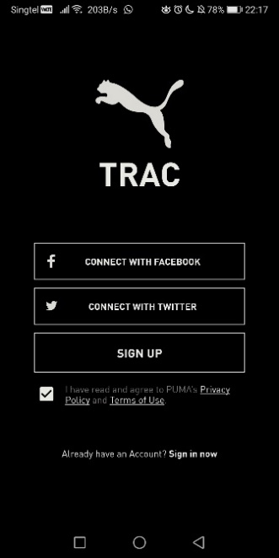
Tapping on the checkbox turns it to white, a good contrast as confirmation that it has been checked. The rest of the buttons are also enabled, once again good contrast that allows user to see the immediate feedback.

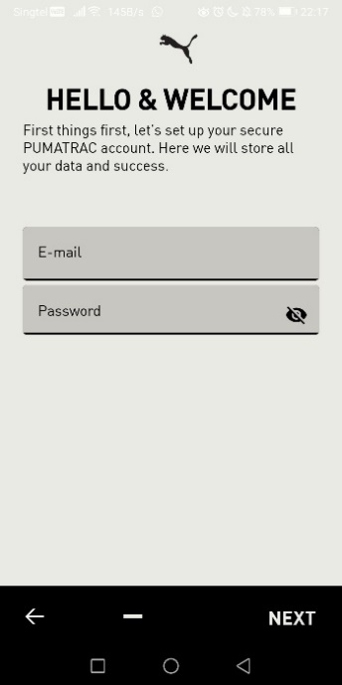
Upon tapping on the “Sign Up” button, the user is brought to the registration page. A huge switch from black to light grey background is quite jarring, different fonts are used for the fields as well. The back button is also located at the bottom left compared to the 2 other apps covered above.
The line at the bottom bar is a progress bar that did not work at all, users can easily confuse it with a minus button for something else. There is no background bar to indicate that it is a progress bar.
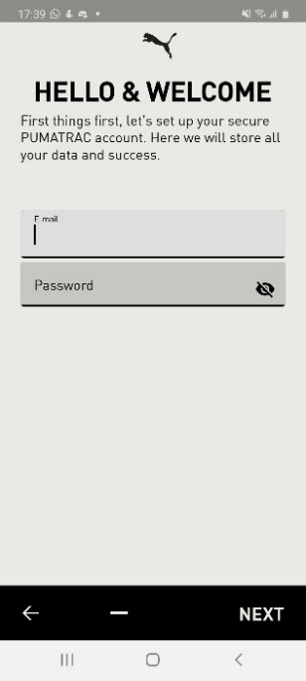
Tapping on the field reduces the font to an almost unreadable size, straining the user’s eyes. The field is also switch from dark grey to light grey to indicate that it is currently selected. One thing to note is how the “next” button is not disabled here despite the fields being empty. It is inconsistent with the register/login page.
Low cognitive load as there are only 2 fields.

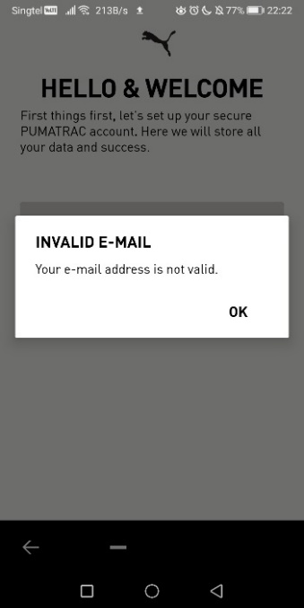
Tapping on “next” without filling up the fields brings a pop-up message that greys out the background. Good contrast to notify the user.

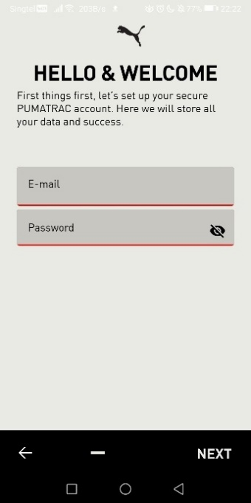
After acknowledging the pop-up, the fields are underlined with a red line. It feels like the pop-up is redundant.
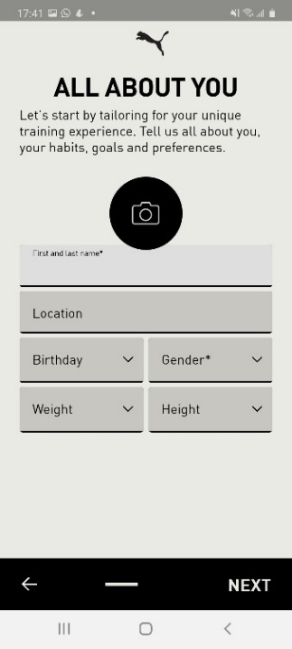
The next page asks the user to fill up personal information, consistent design language for all the fields. This page could have been split into 2 pages to reduce the cognitive load on the user.

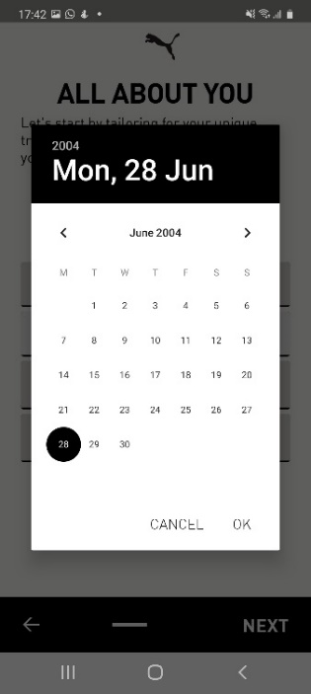
Tapping on the birthday drop down brings a calendar pop-up to choose your birthday. This navigation feels too complicated for a simple birthday selection. A simple scrolling for each element of day, month and year would have been a better choice.

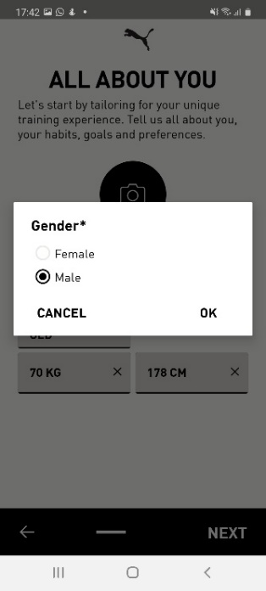
Gender selection is very simple and easy to understand. 2 choice pop up.

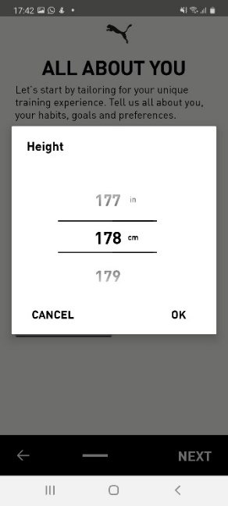
Height selection is a scrollable element. It also provides metric and imperial measurements, although it would have been more intuitive if there was button to switch between the two. Right now, it looks like it is tied to the number.

Customizing
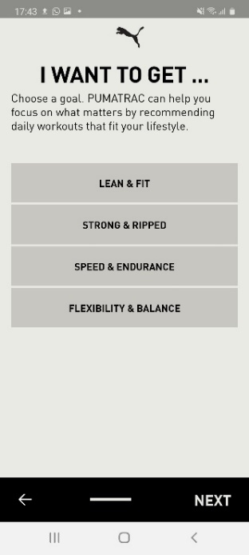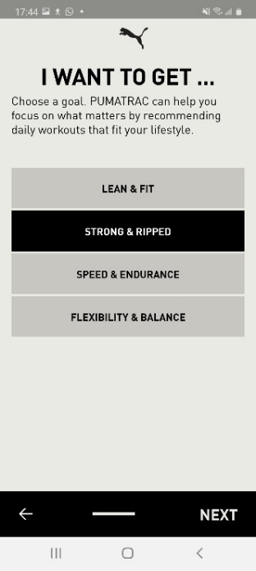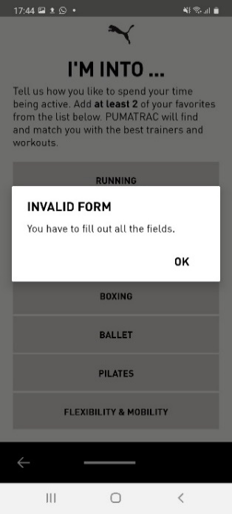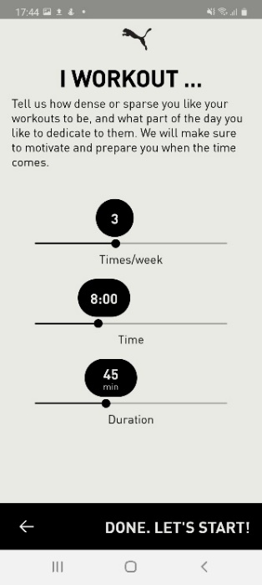
Analysis on Customizing
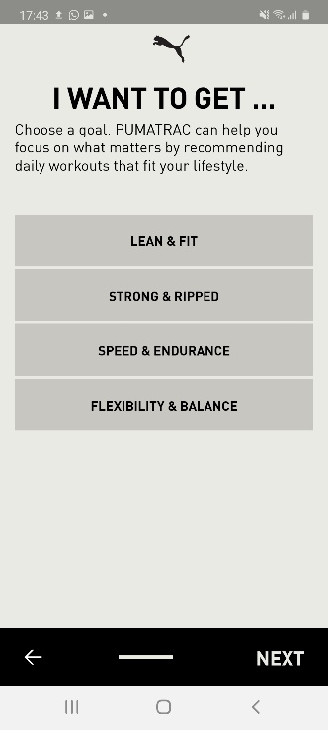
Puma logo is ever present, the font size is huge to emphasise on what the page is asking to user. Simple 4 choice selection which works well.

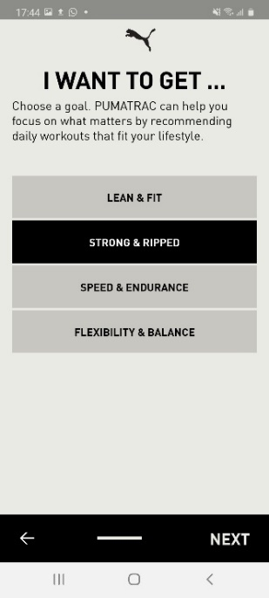
Selecting one turns it into a black box with white words, a huge contrast against those that are not selected.

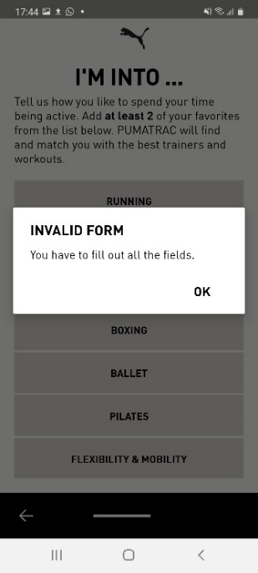
Not selecting an option and tapping next, brings up the same pop-up error message seen in the registration process.

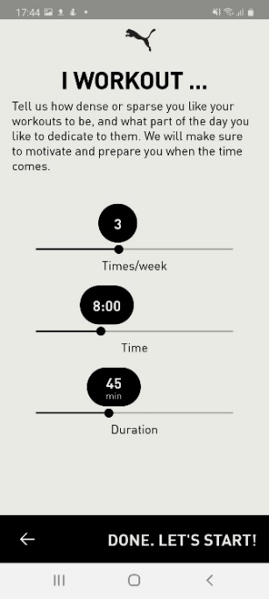
There is a sudden change in filling style, when the user is asked about their workout frequency and intensity it turns into sliders. It is very jarring; they could have used the scrollable selection which was used when asking for the user’s weight/height.
The progress bar line also disappeared. It is replaced with a huge text button instead.
Workout
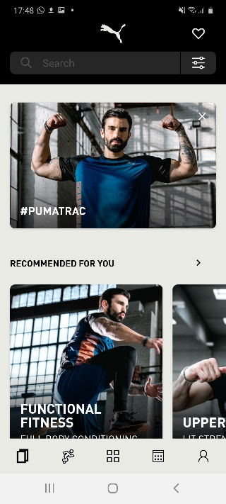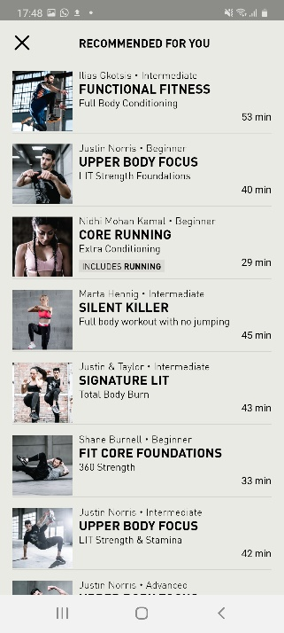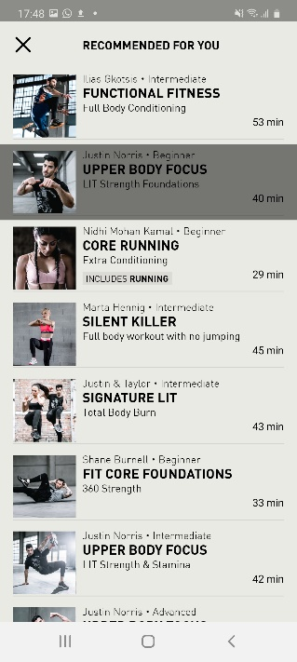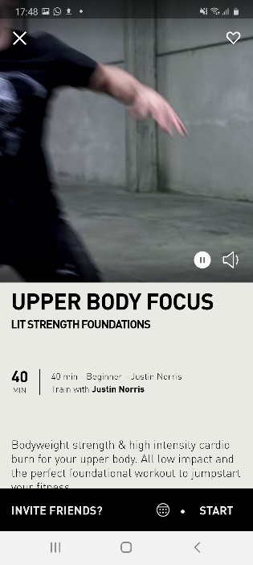
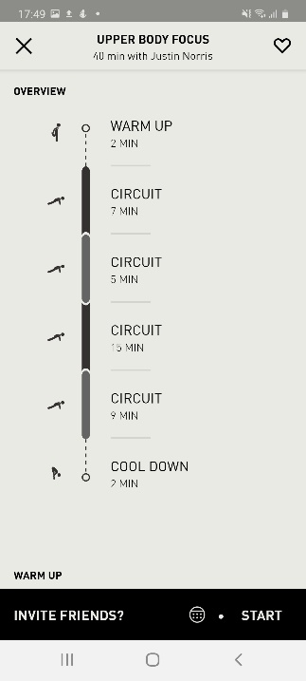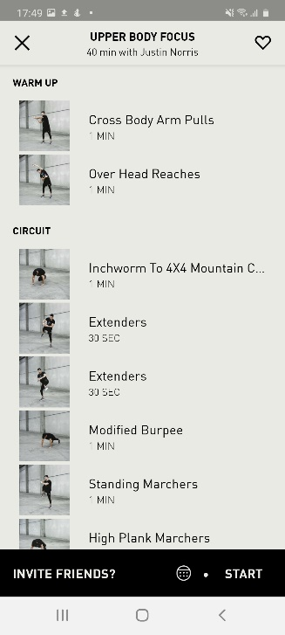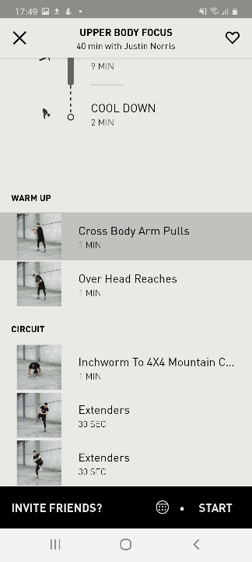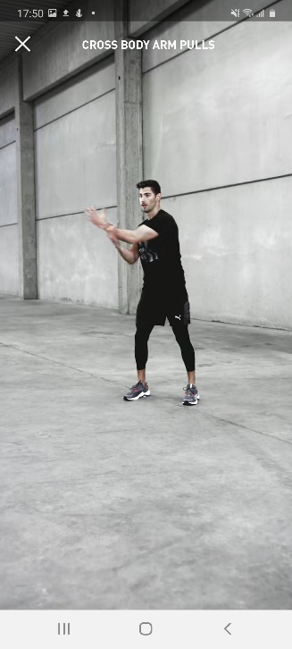
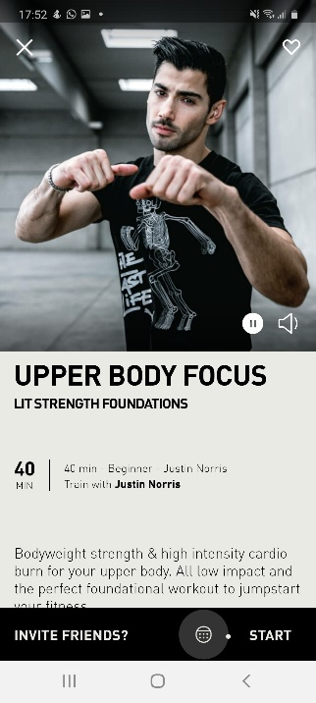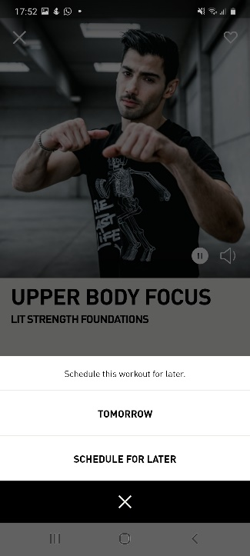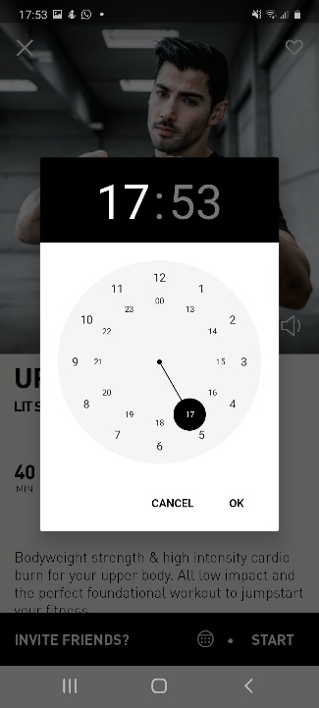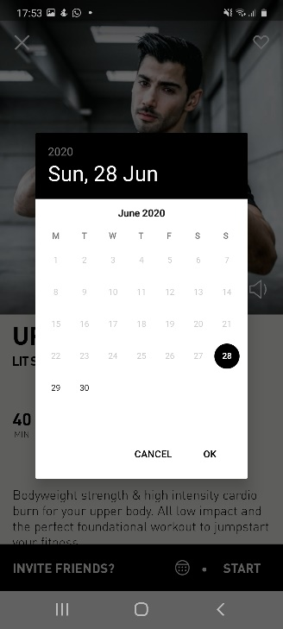
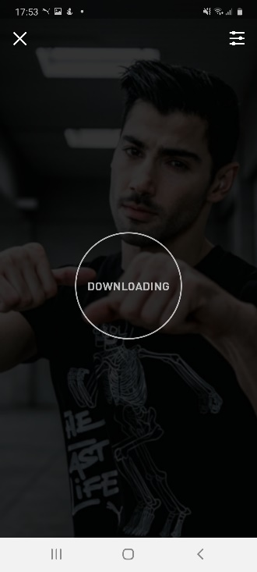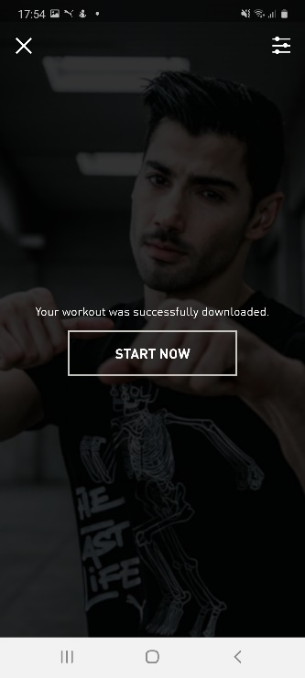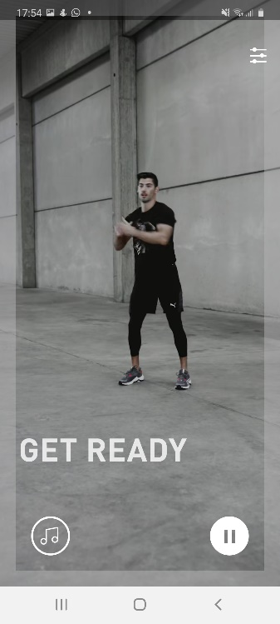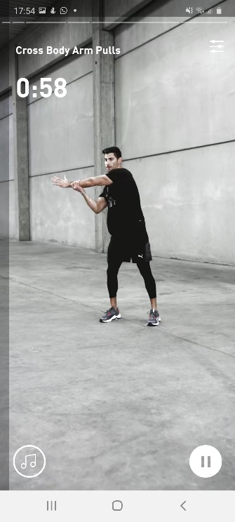
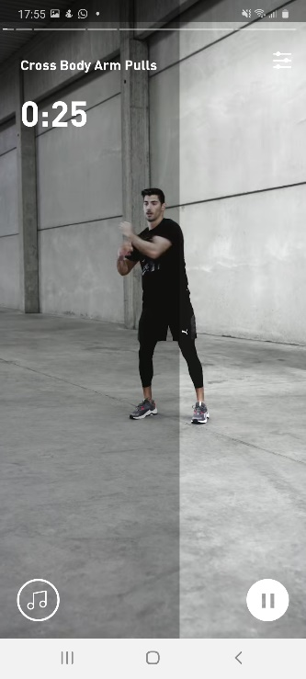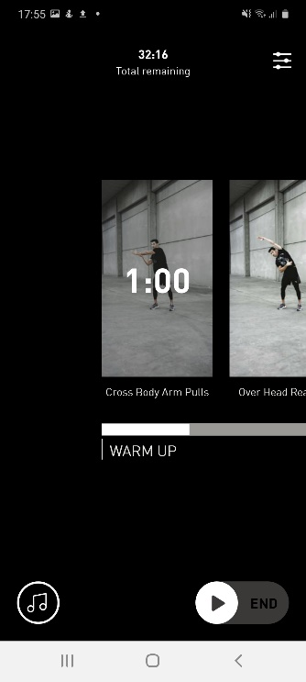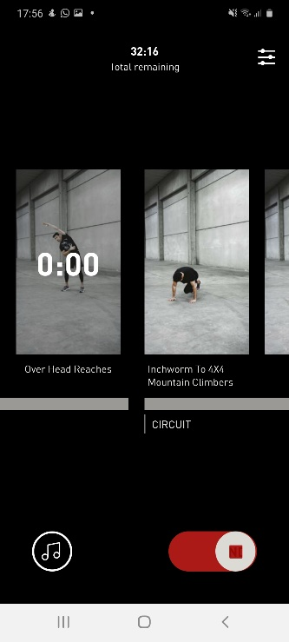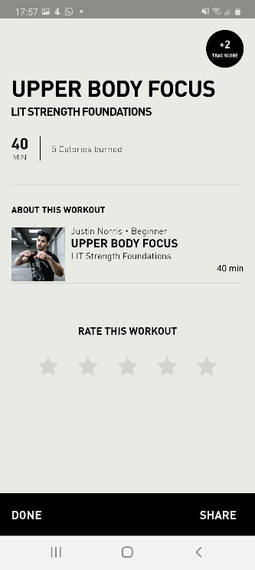
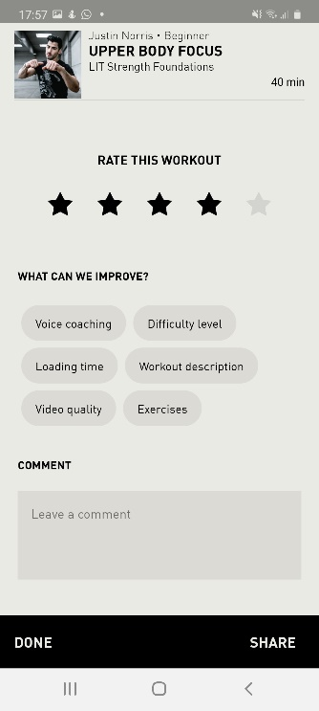
Analysis on Workout
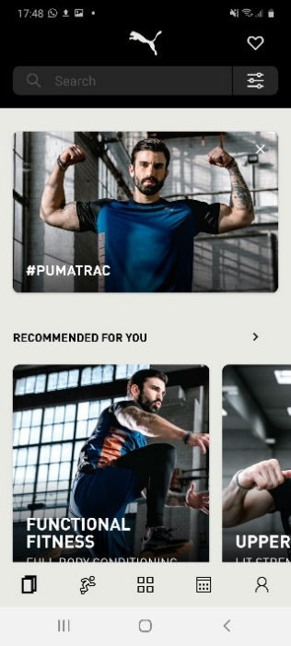
Right after completing the customising process, nothing happens. The user is brought to the main page where the first thing the user sees is the #PUMATRAC button that leads the user to the PUMA store. Extremely confusing, did the user just download a shopping app? It makes the app seem like it is pushing PUMA products instead of caring for the user’s fitness.
The workout is located at the Recommended for you section below the shop button.

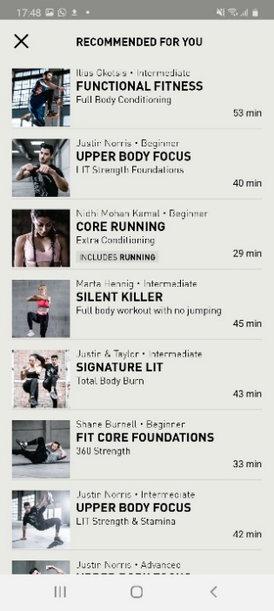
Recommended for you page is a pop up that shows all workouts available as a scrolling list. It displays the title, a short description and duration of workout.

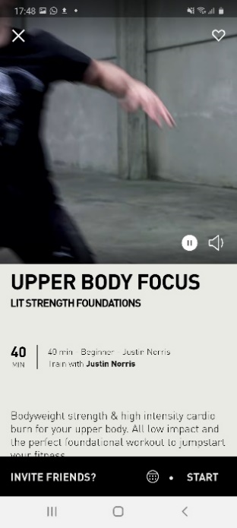
Selecting one of the workouts brings the user to the workout’s page. It shows the description with a video of the trainer doing some of the exercises.
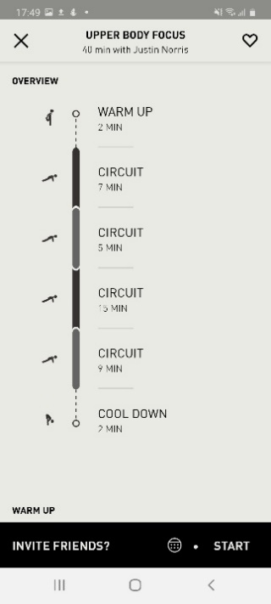
Scrolling down shows the overview in a road map format that breaks down each part of the exercise accordingly. This is easy for users to understand compared to the other 2 apps.

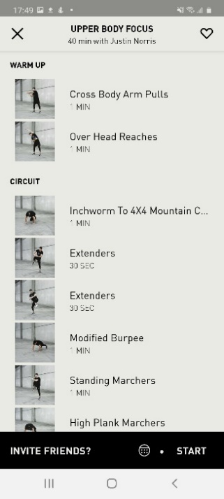
Scrolling further down, shows all exercises to be done in list form with the duration of each exercise.

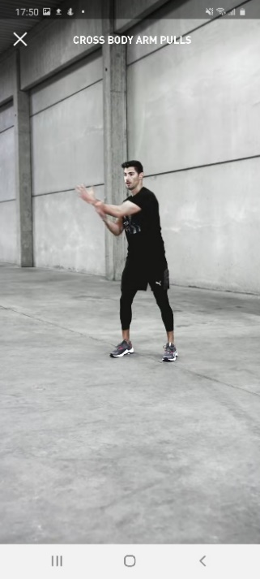
Tapping on any exercise will bring another pop-up which is a video that covers the entire screen with the title of the exercise in small white font at the top. The video could have been zoomed in further and title size could have been increased for better visibility.
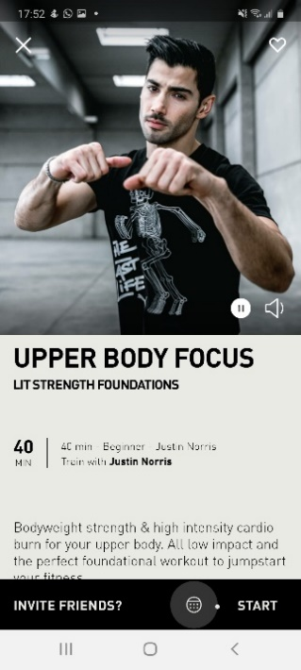
Tapping on the rounded icon on the bottom bar. This feedback is consistent for most buttons in the app. There will be a light grey highlight of the button.

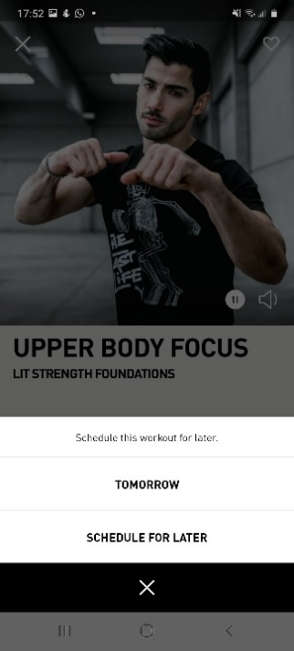
The round icon brings up a pop-up that allows the user to schedule the workout for later. The two options are essentially the same thing, having the “Schedule for later” button is more than enough.

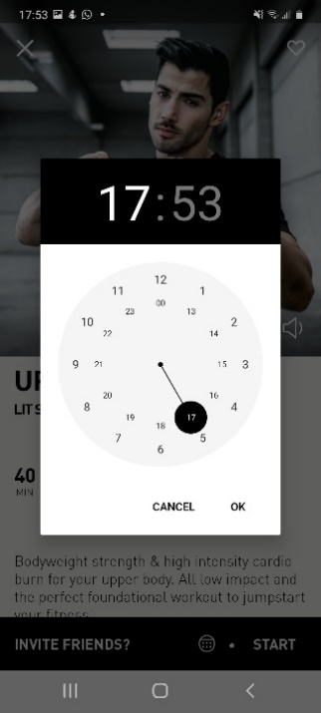
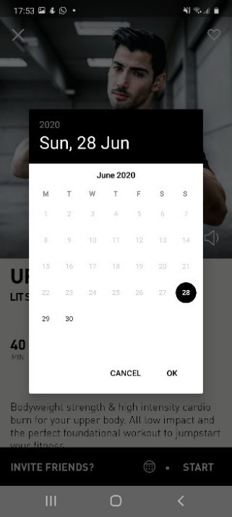
It does not help that both buttons provide different interfaces. Having one button that provides date and time would provide a much smoother experience.
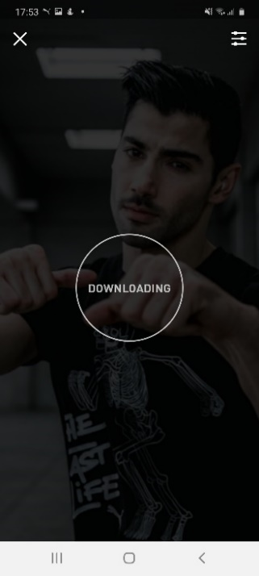
Tapping on “Start” brings this screen up where the app starts downloading the videos required for the workout. This could have been placed before entering the workout page. Now the user needs to wait when they are all pumped up to start the workout. There is also no animation to indicate the progress of download or that it is working.

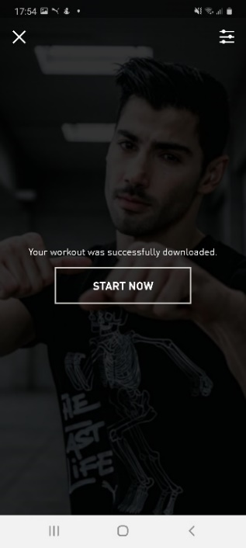
Confirmation message of download completed.

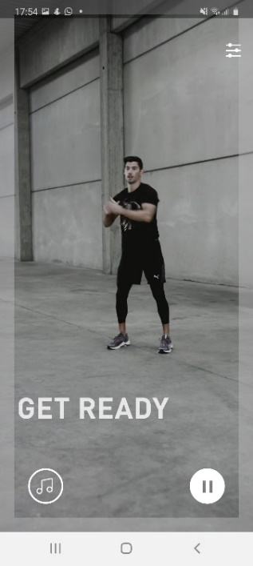
Starting of workout, a get ready screen with no timer. When is the user supposed to get ready by? The video of the man jumping about does not help. This screen stays on for 10 seconds.
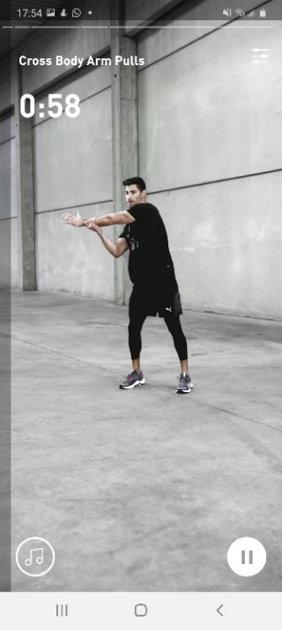
Exercise starts, a small timer at the top corner with the title of the exercise. The video demonstrates the exercise accordingly. The font sizes could have been increased for better visibility, there is a lot of wasted space on this screen.

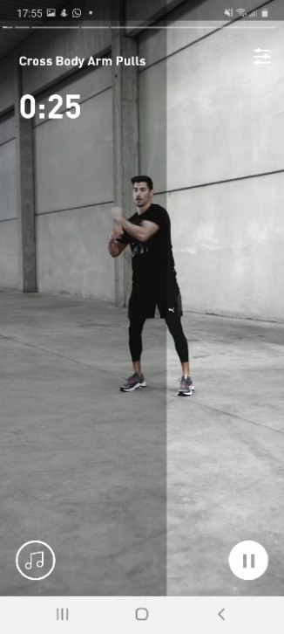
A grey overlay moves from left to right following the amount of time left as additional feedback to show the progress of the exercise.

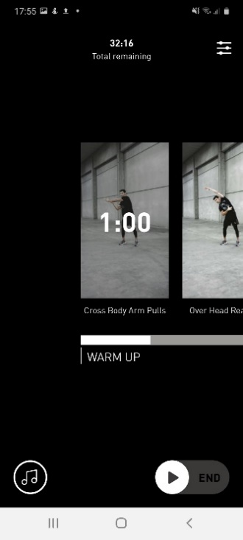
Tapping on the pause button brings up this black screen which scrolls from left to right to see overall progress and the user is also able to skip ahead to another exercise by tapping on the appropriate picture.
The resume button and end button are part of the same UI element which makes it confusing. It looks like a sliding play button to end, however upon tapping on the play icon it resumes the exercise.

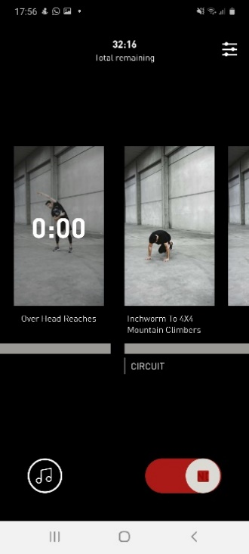
Sliding the play icon turns the slider to red with a stop icon that cannot be seen by the user as the element is so small it gets covered up by the user’s finger.

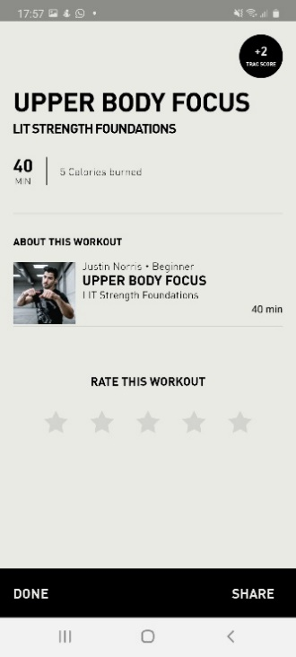
End of the workout page, there is a point system that the user does not know anything about. It also shows the workout title twice and the duration twice as well as the calories burned.
User’s can also choose to rate and share the workout.

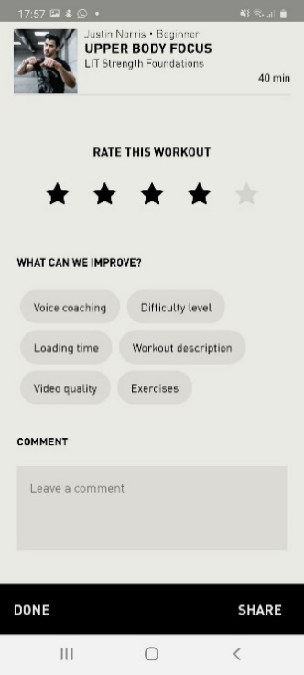
Tapping on any rating star expands the form to allow for additional feedback from the user.

